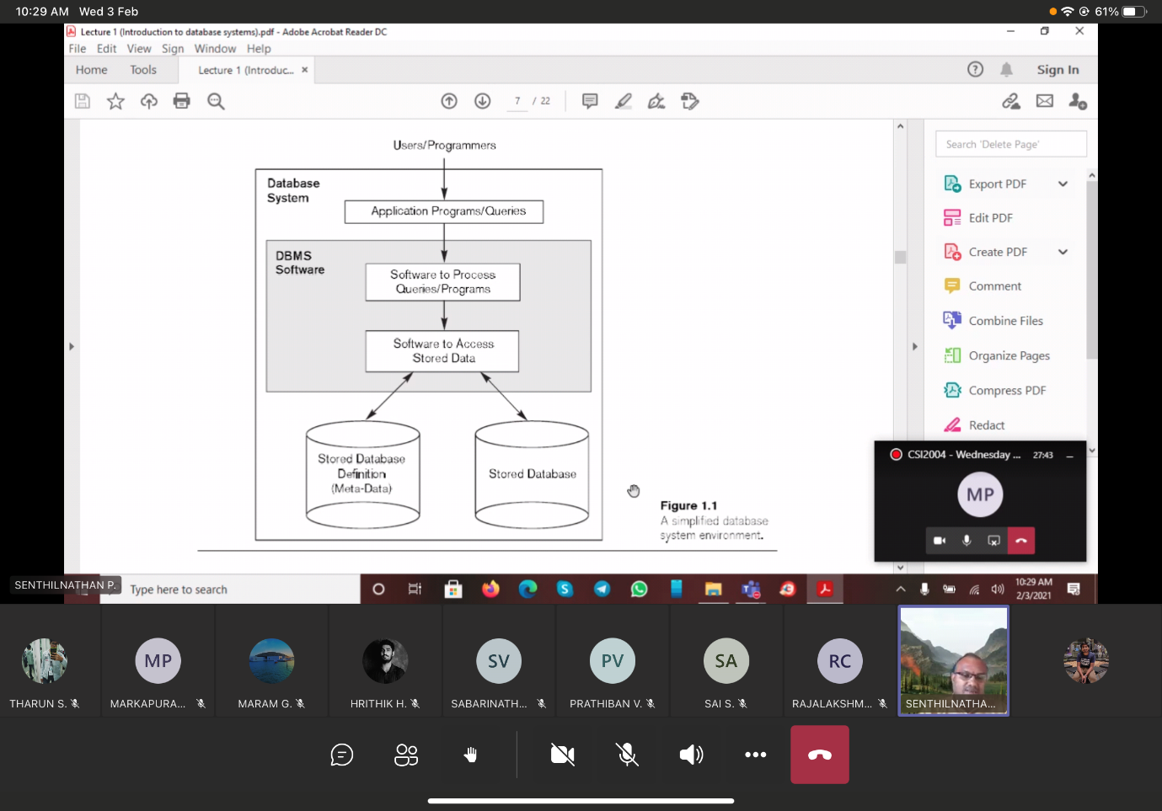

Parser  
Operator evaluator 🡪   
Optimizer 🡪

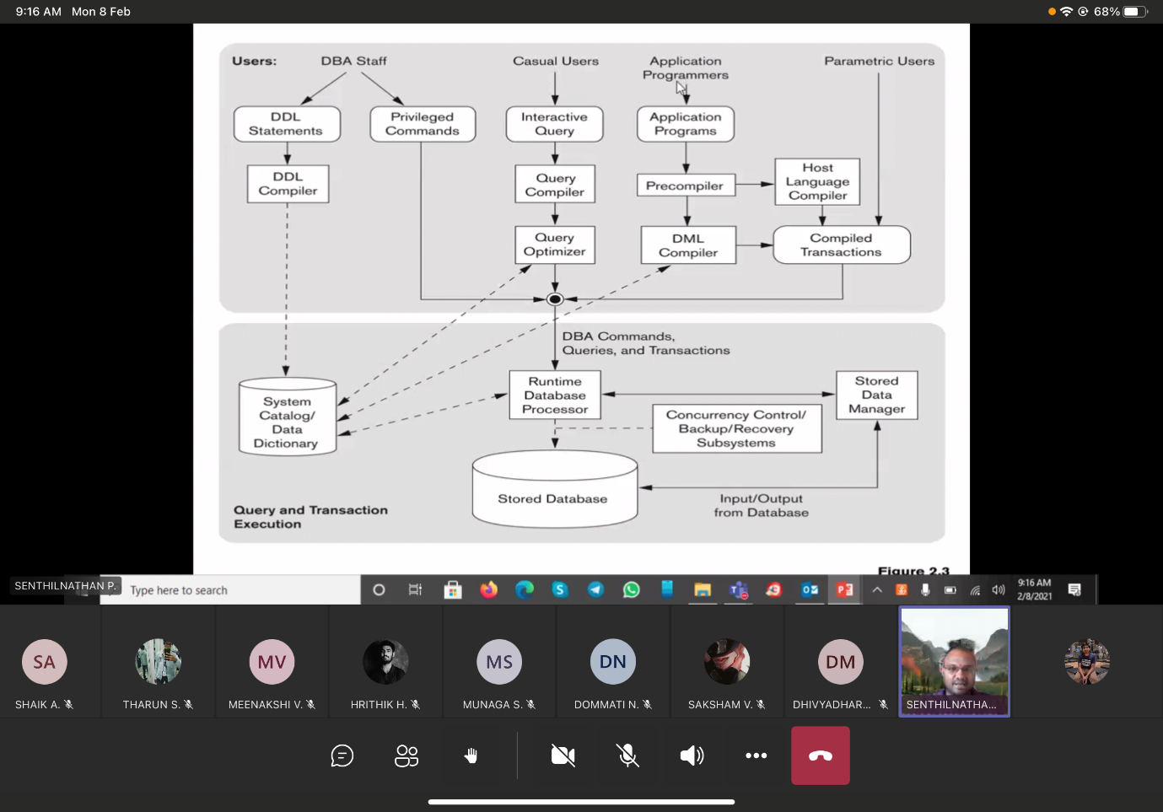

1) Data Base Models 🡪 Logic design of the data  
2) Hierarchical Data Base Model 🡪 tree structure manner. 1 parent (root) and any number of child.  
3) Network data-base model 🡪 Organized in the graphical format.  
4) Relational data-base model 🡪 2 dimensional tables (row and column) 🡪 relation. Every relation is inter-connected.  
5) Distributed data-base model 🡪 Data is stored in several computers   
6) Object-oriented data-base model 🡪 advantages of Relational model + applications to access structured data.  
7) fragmented data-base model 🡪   
8) Replicated distributed data-base model 🡪 Updated data will be available every time at every site.  
9) XML(Extensible Mark-up Language) 🡪   
10) Extended Relational Data Model (ERDM) 🡪

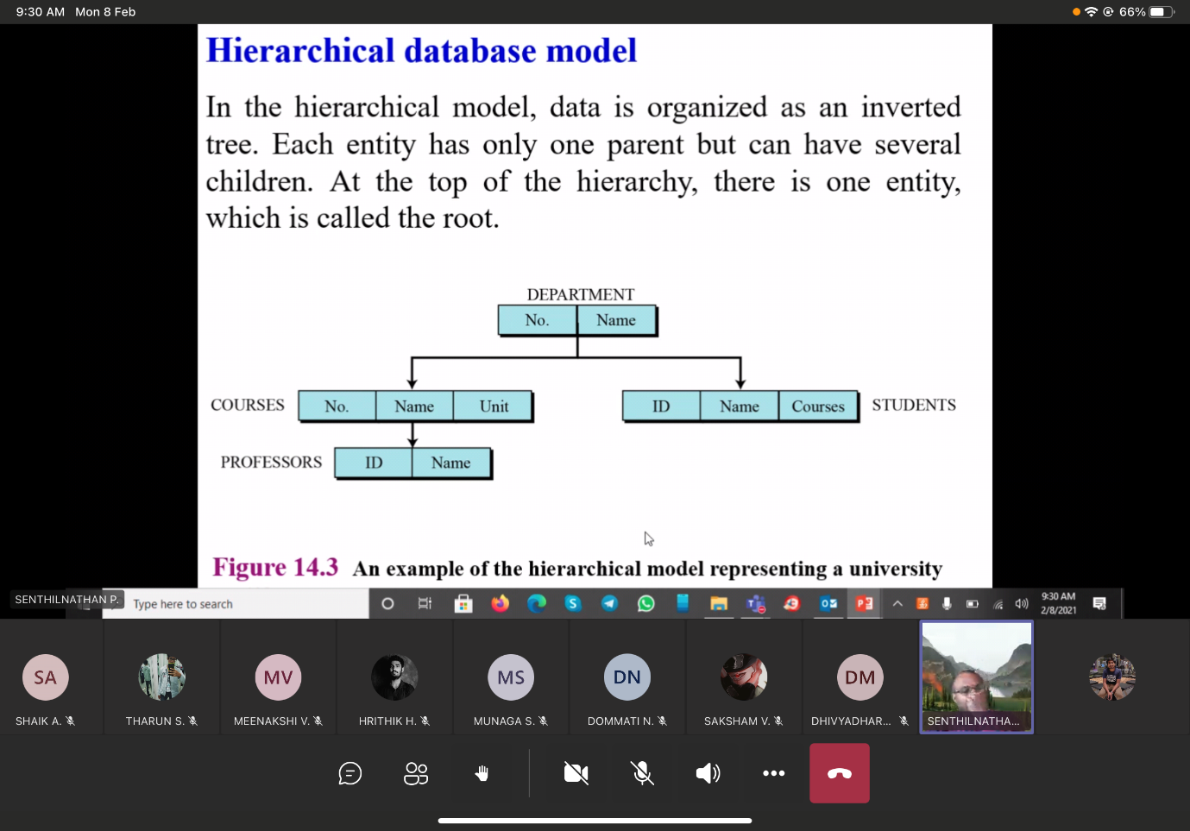

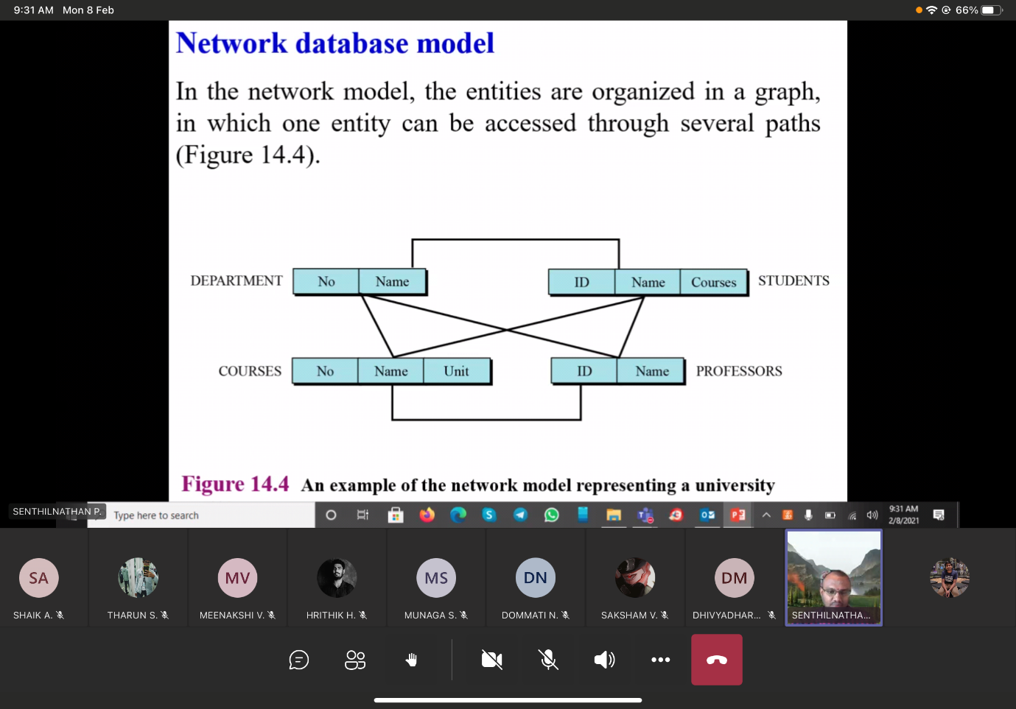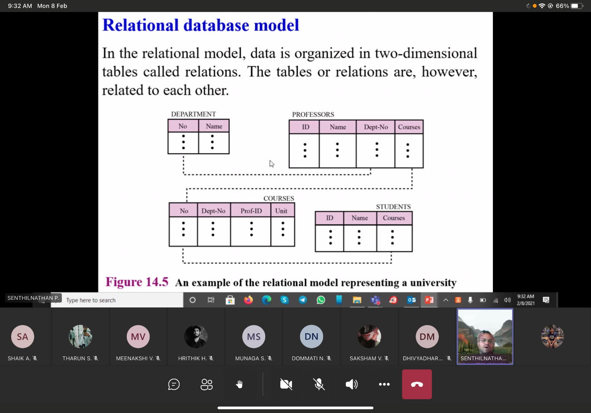

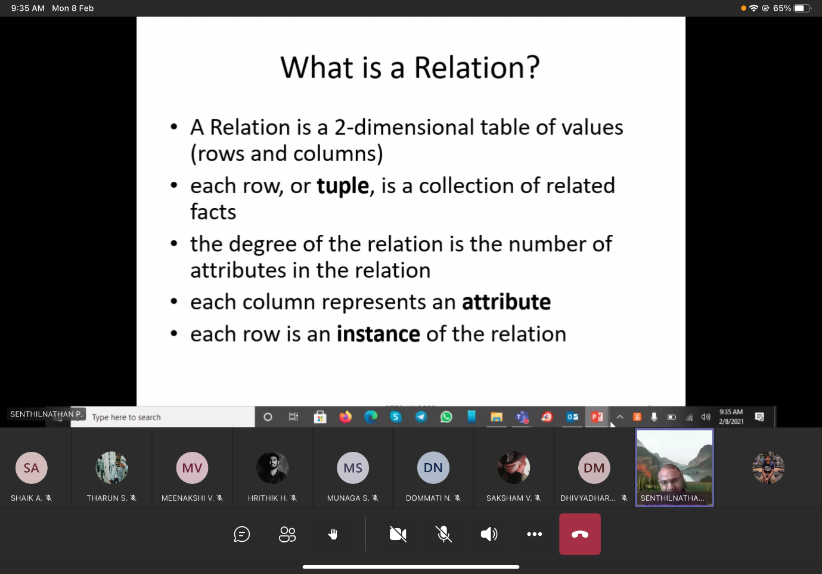

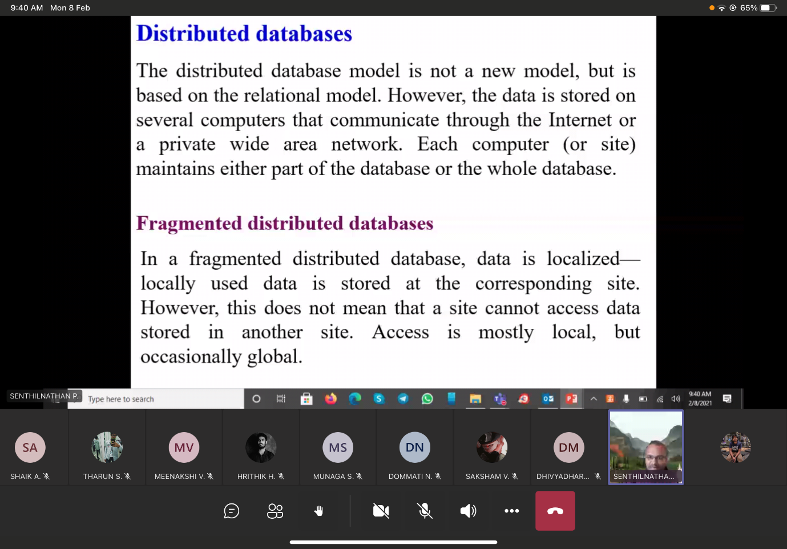

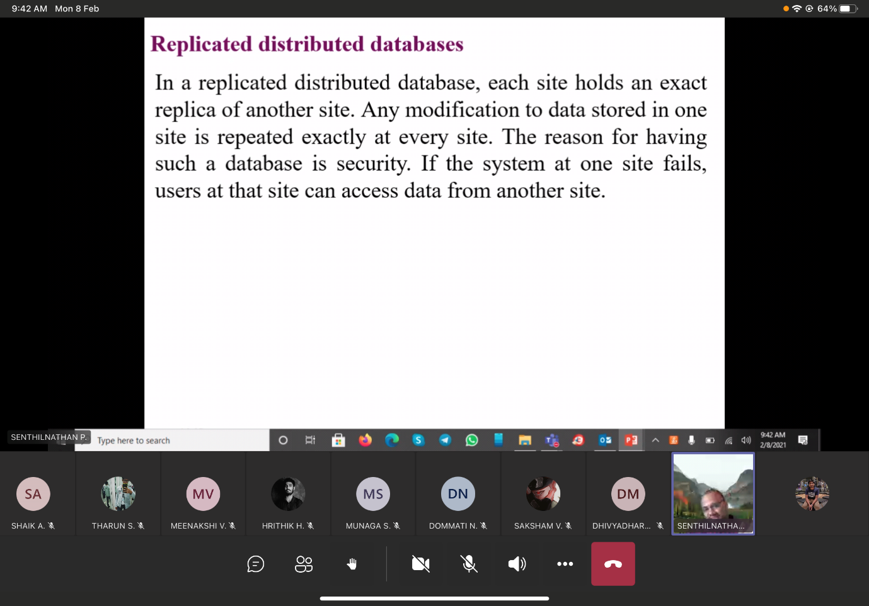

**Structured Query Language**Standardized by   
1) Insert 🡪  
2) Delete 🡪  
3) Update 🡪  
4) Select 🡪   
5) Project 🡪   
6) Join 🡪 Combines two relations on a common attribute.  
7) Union 🡪   
8) Difference 🡪

ER diagram(Entity relationship)

Properties that describes the entity 🡪

**Types of attribute:**

**Weak entity 🡪 this entity will not have primary key. It will depend on owner key.**

EER diagram(Enhanced-Entity relationship)

**Query code generator** 🡪 Query to code  
1)Interpreted mode 🡪 Executed directly after it has been generated.  
2)Compiled mode 🡪 Storing and executing when-ever we want.

**Nested query**Entire query will not be considered as single query block.  
Every separate query will have a separate query blocks.

And then the required relational algebra expression is generated.

Inner query projection 🡪 delta  
Outer query projection 🡪 pi



**SSN 🡪 Social Security Number**

Appropriate access (independent access)

1)select-1(5 rows)  
2)select-2(10 rows)  
Which selection will have only smaller number of records (select-1) 🡪 This will be selected first by the query optimiser, then only next selection(select-2) will take place.  
This decision will be done by the **query optimiser.**

**Implementing the JOIN operation**

**Nested outer loop join** :   
**Single loop join :**  
**Sort merge join :** When the two relations are sorted based on that joint value, Then two relations are joined using a Sort merge join.  
**Hash-join :** When the two relations are hashed based on that joint value, Then two relations are joined using a hash-join.

When both the relations

**\*Selecting and keeping separately .  
And then applying Group BY**

**Outer join :**

dno.employee = dnumber.department

Using heuristics in Query Optimisation

Query tree 🡪

Leaf nodes 🡪 Plocation = ‘Stafford’ and D  
Inner nodes 🡪

Project table 🡪 DNUM, PNUMBER, PLOCATION  
Department table 🡪 DNUMBER, MGRSSN  
Employ table 🡪 all the employ details.

Selectivity ratio is also less and When the operand is available that will be given the preference,  
PLocation = ‘Stafford’

**15/2/2021**

**Using heuristics in query optimization**

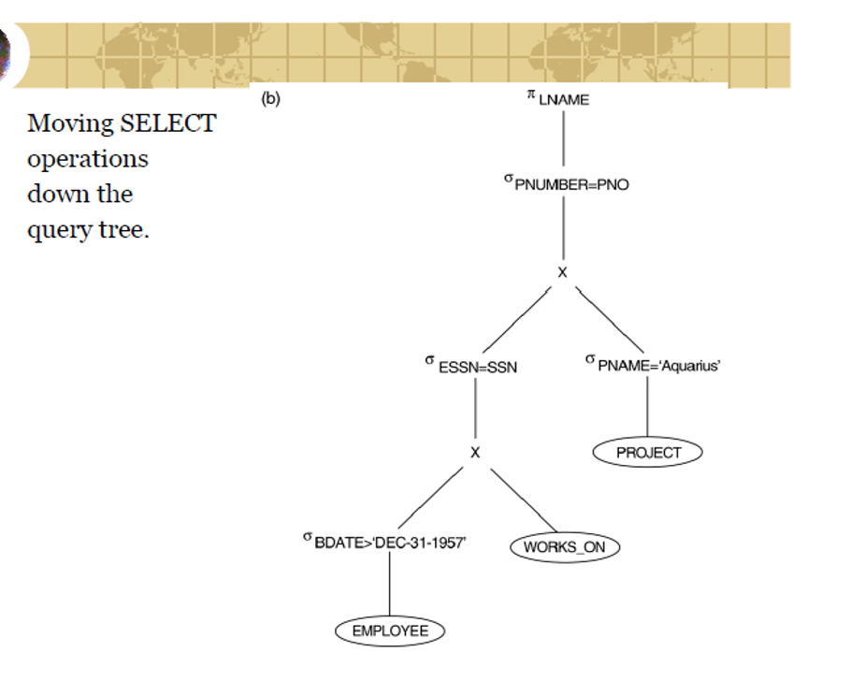

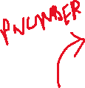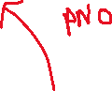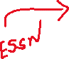

**Final answer**

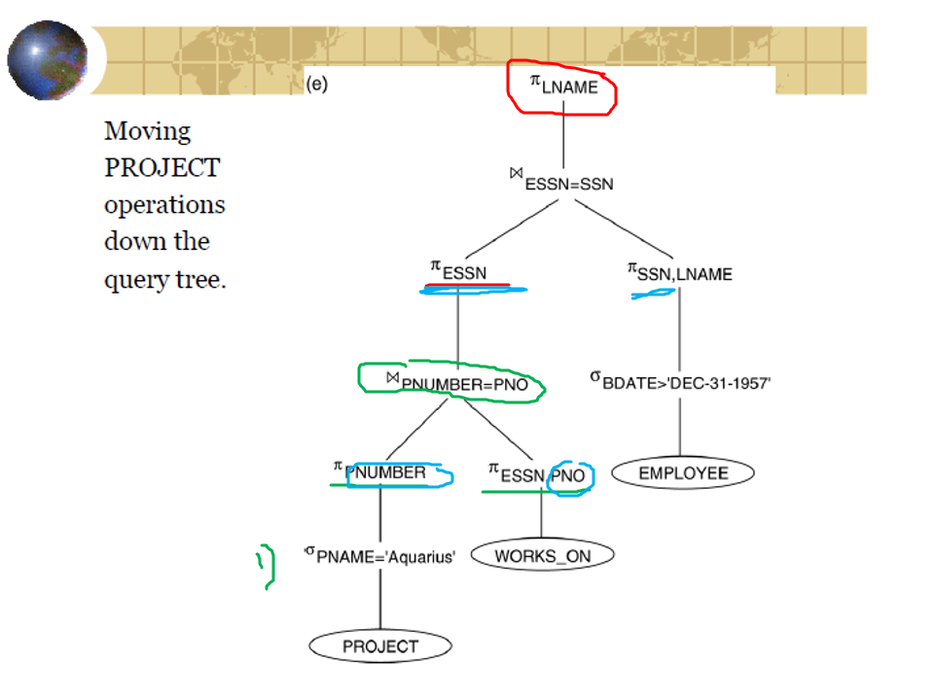

**17-02-2021**

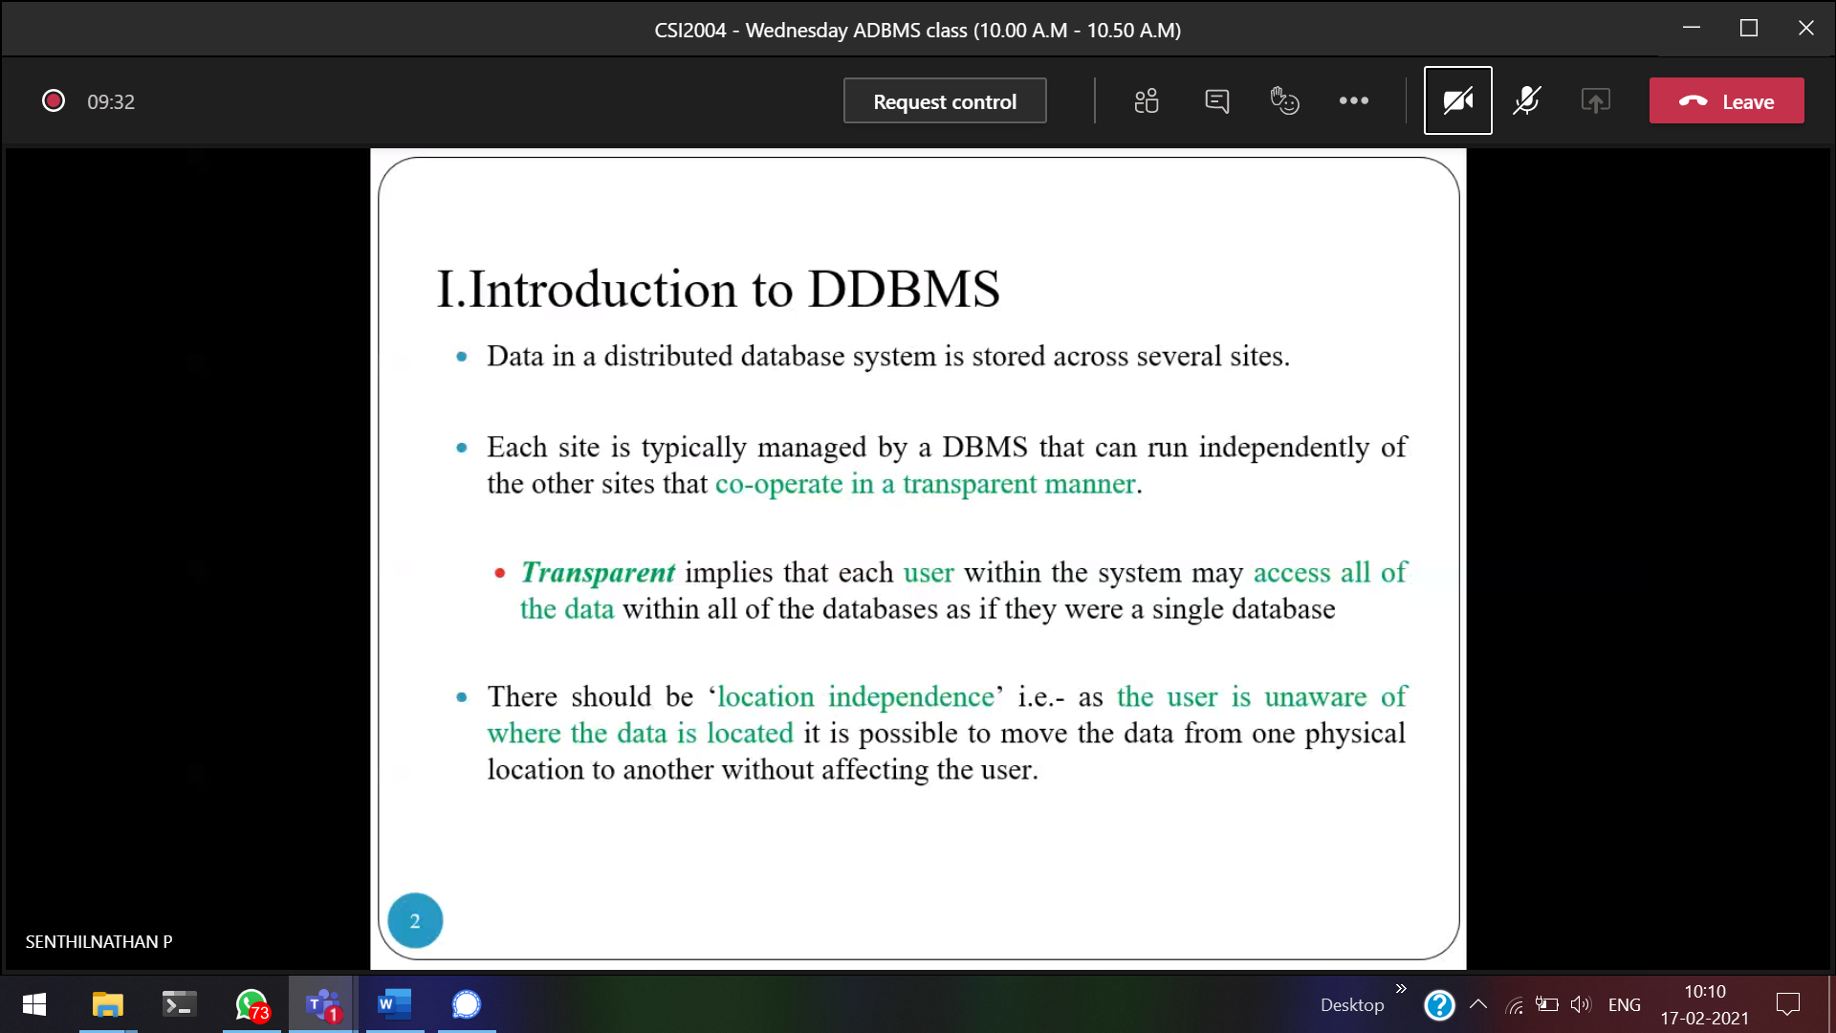Same data will be stored in several servers  
Transparency 🡪 user have the illusion that he/she access the data-base from a single PC. And all the data-bases are stored in a single place.  
Location Independence 🡪 user will not know where the actual data is stored. User will give 1 query, and get the result.

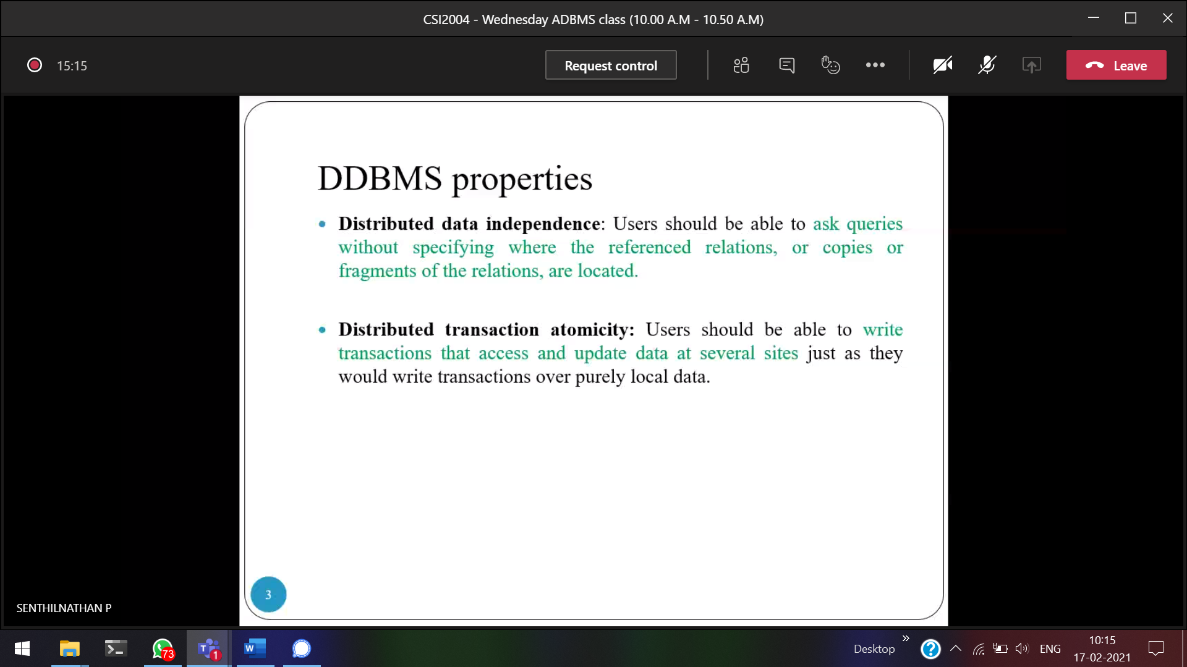

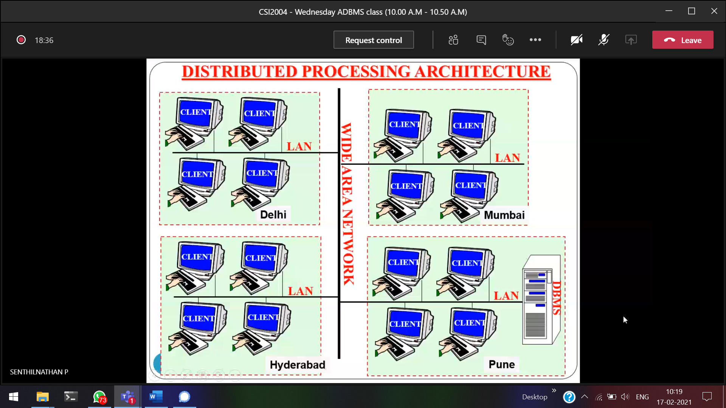

The above is Homogeneous (centralized DBMS)  
Or every site can have individual DBMS 🡪 Heterogeneous

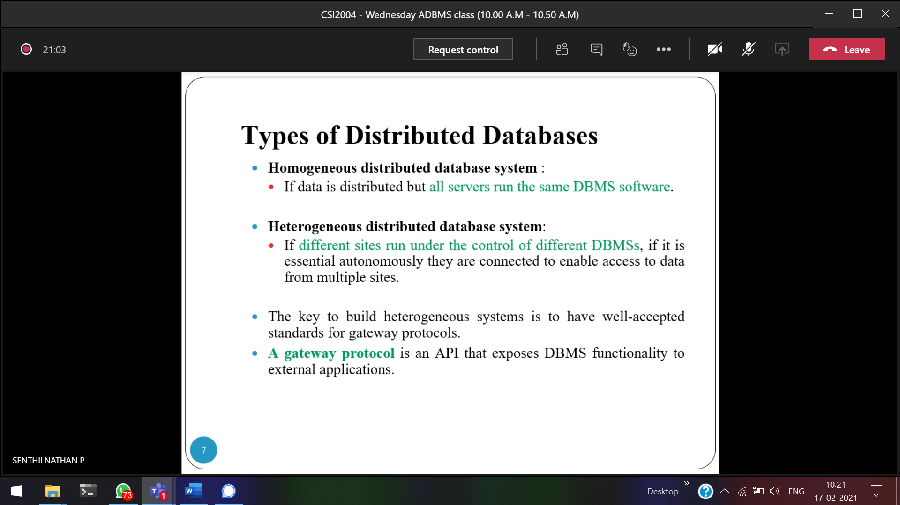



**Architecture of DDB’s**

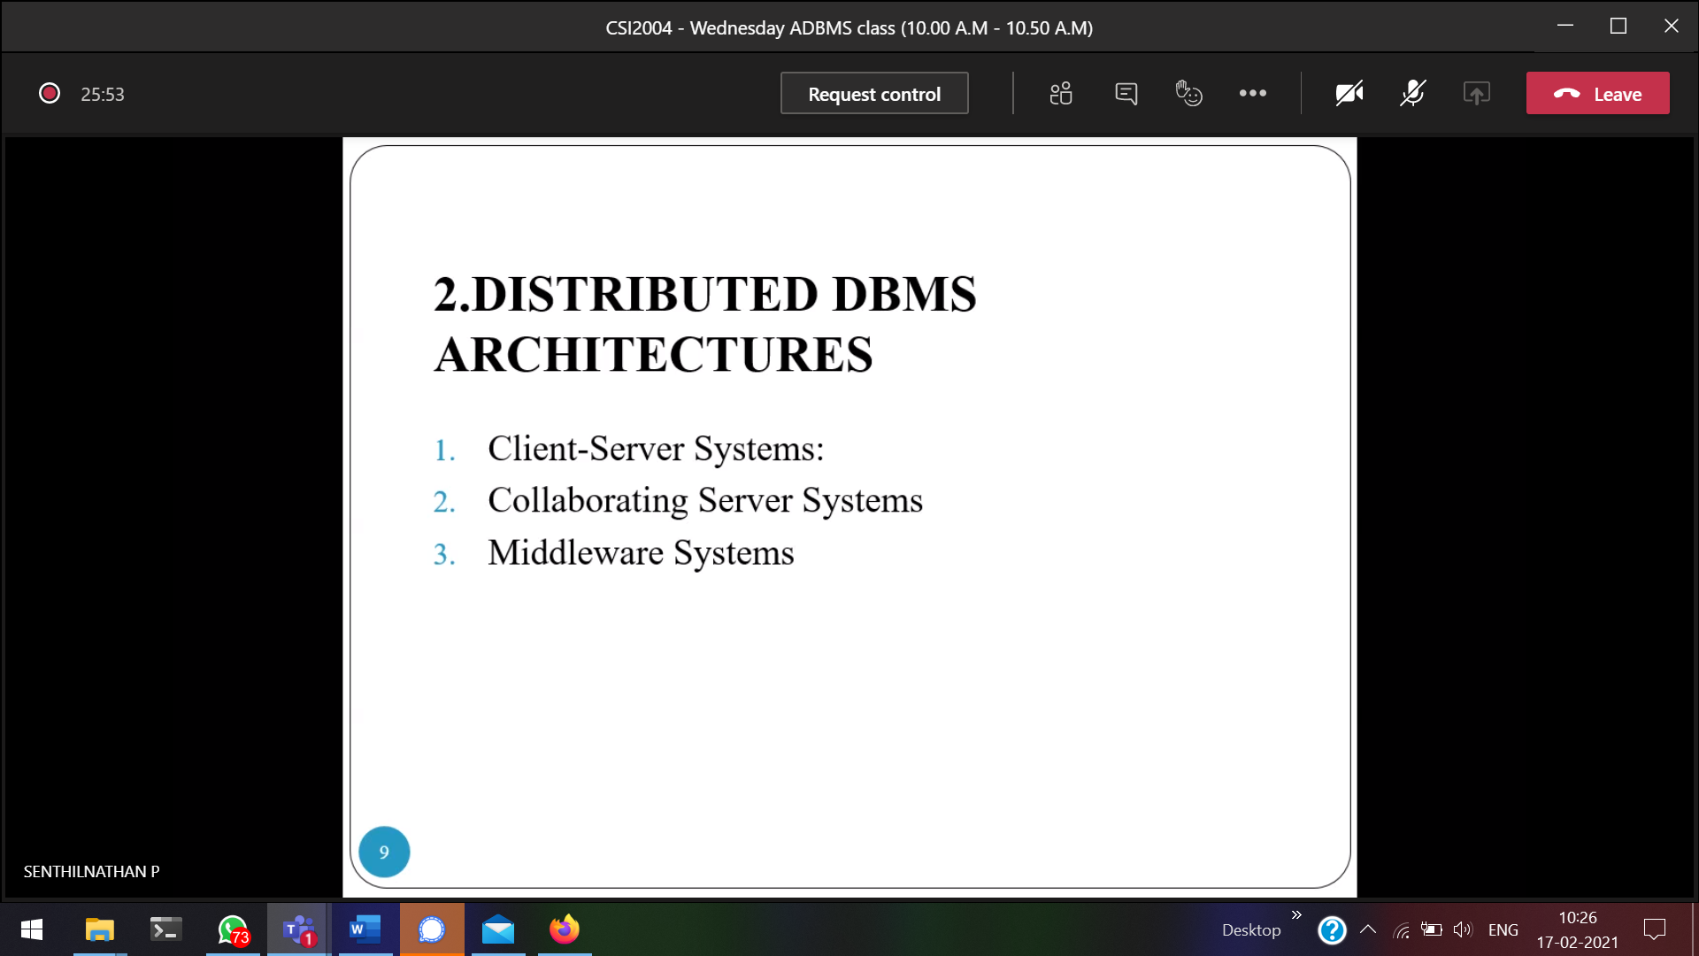

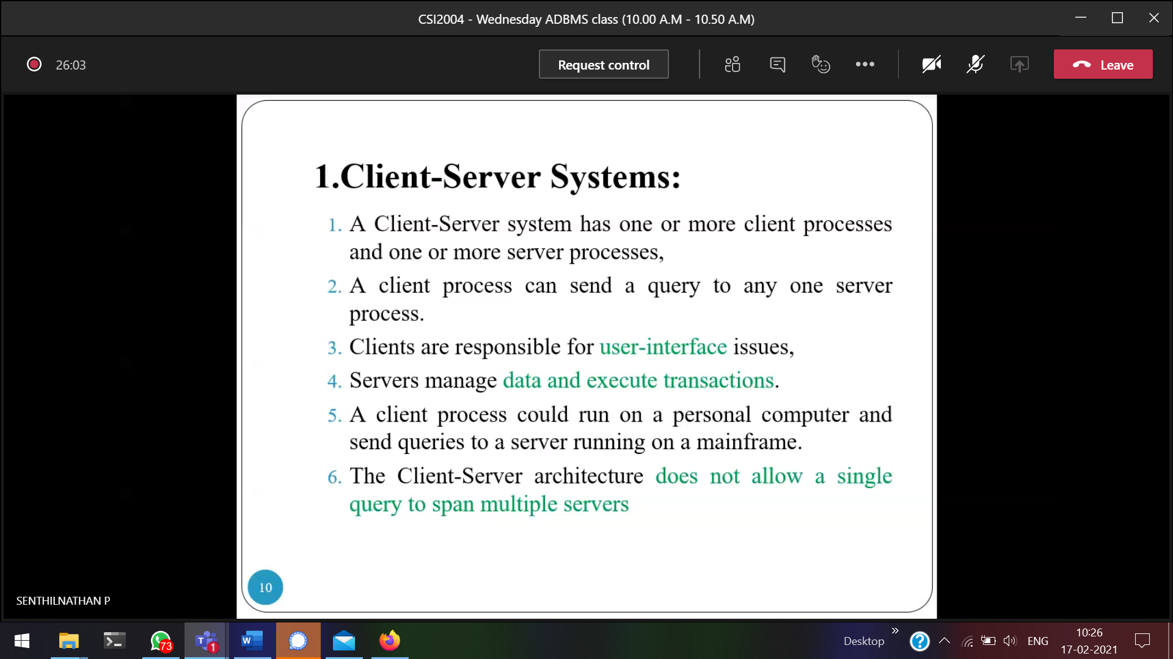  
Query cannot move across multiple servers [one client 🡪 one server]

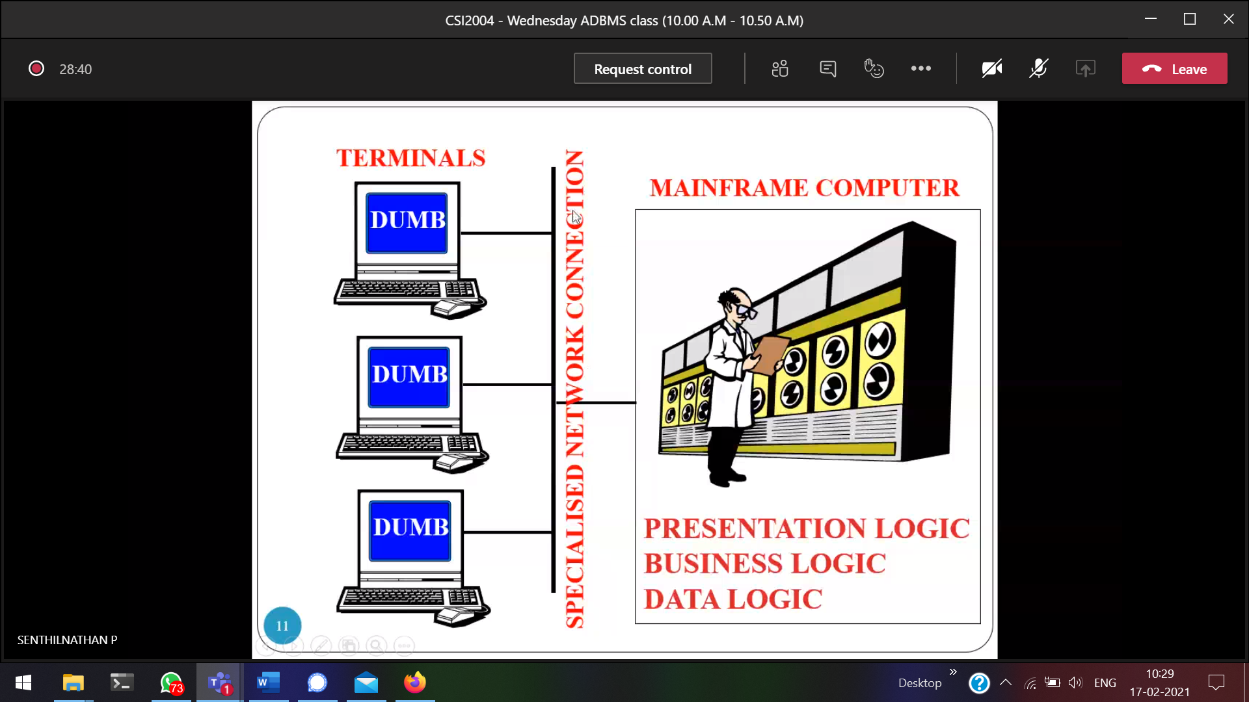

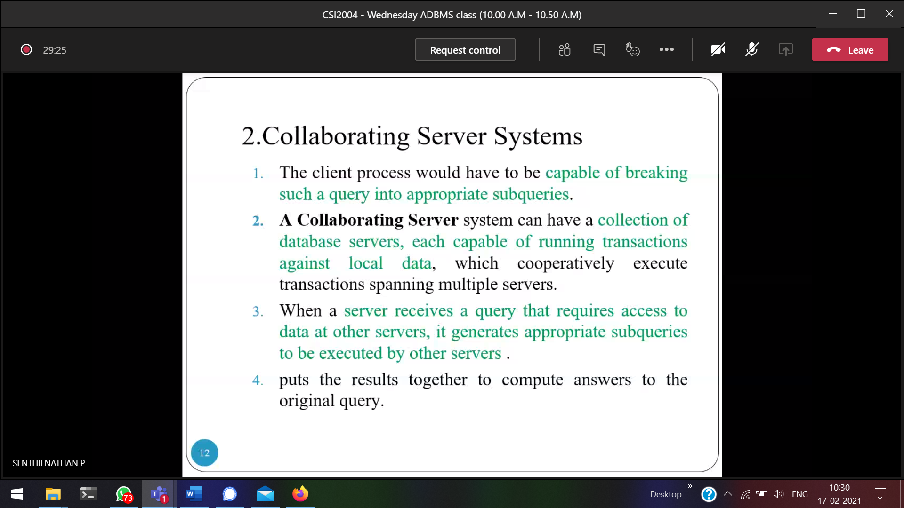  
We can move across multiple servers.  
Query 🡪 (Server-1)When we have no data in a particular server, it Will generate a sub-query and pass to several servers, till getting the data. After that all the sub-query will be consolidated and send it to the front-end.

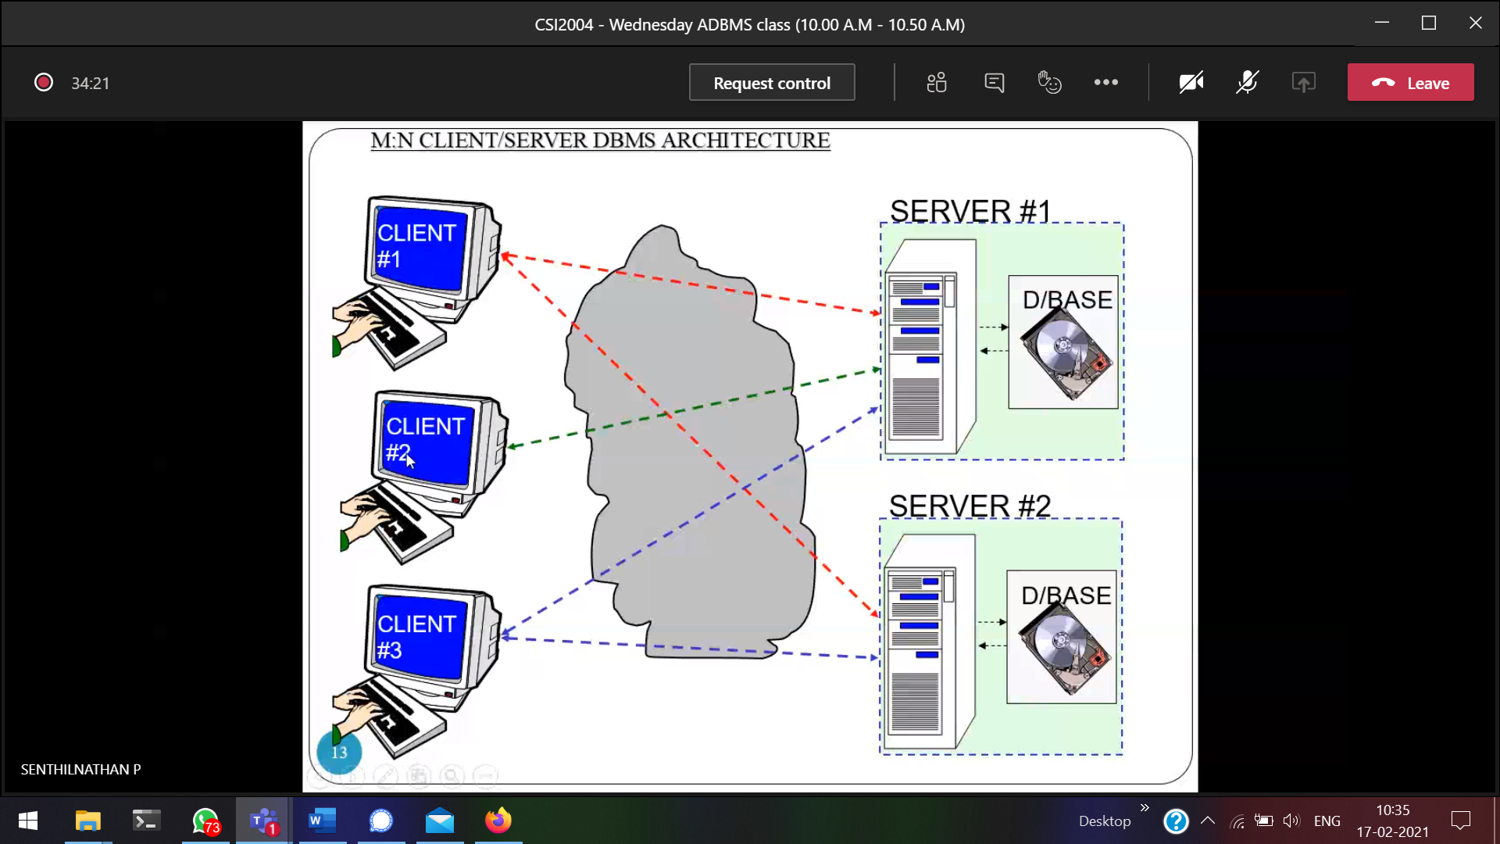

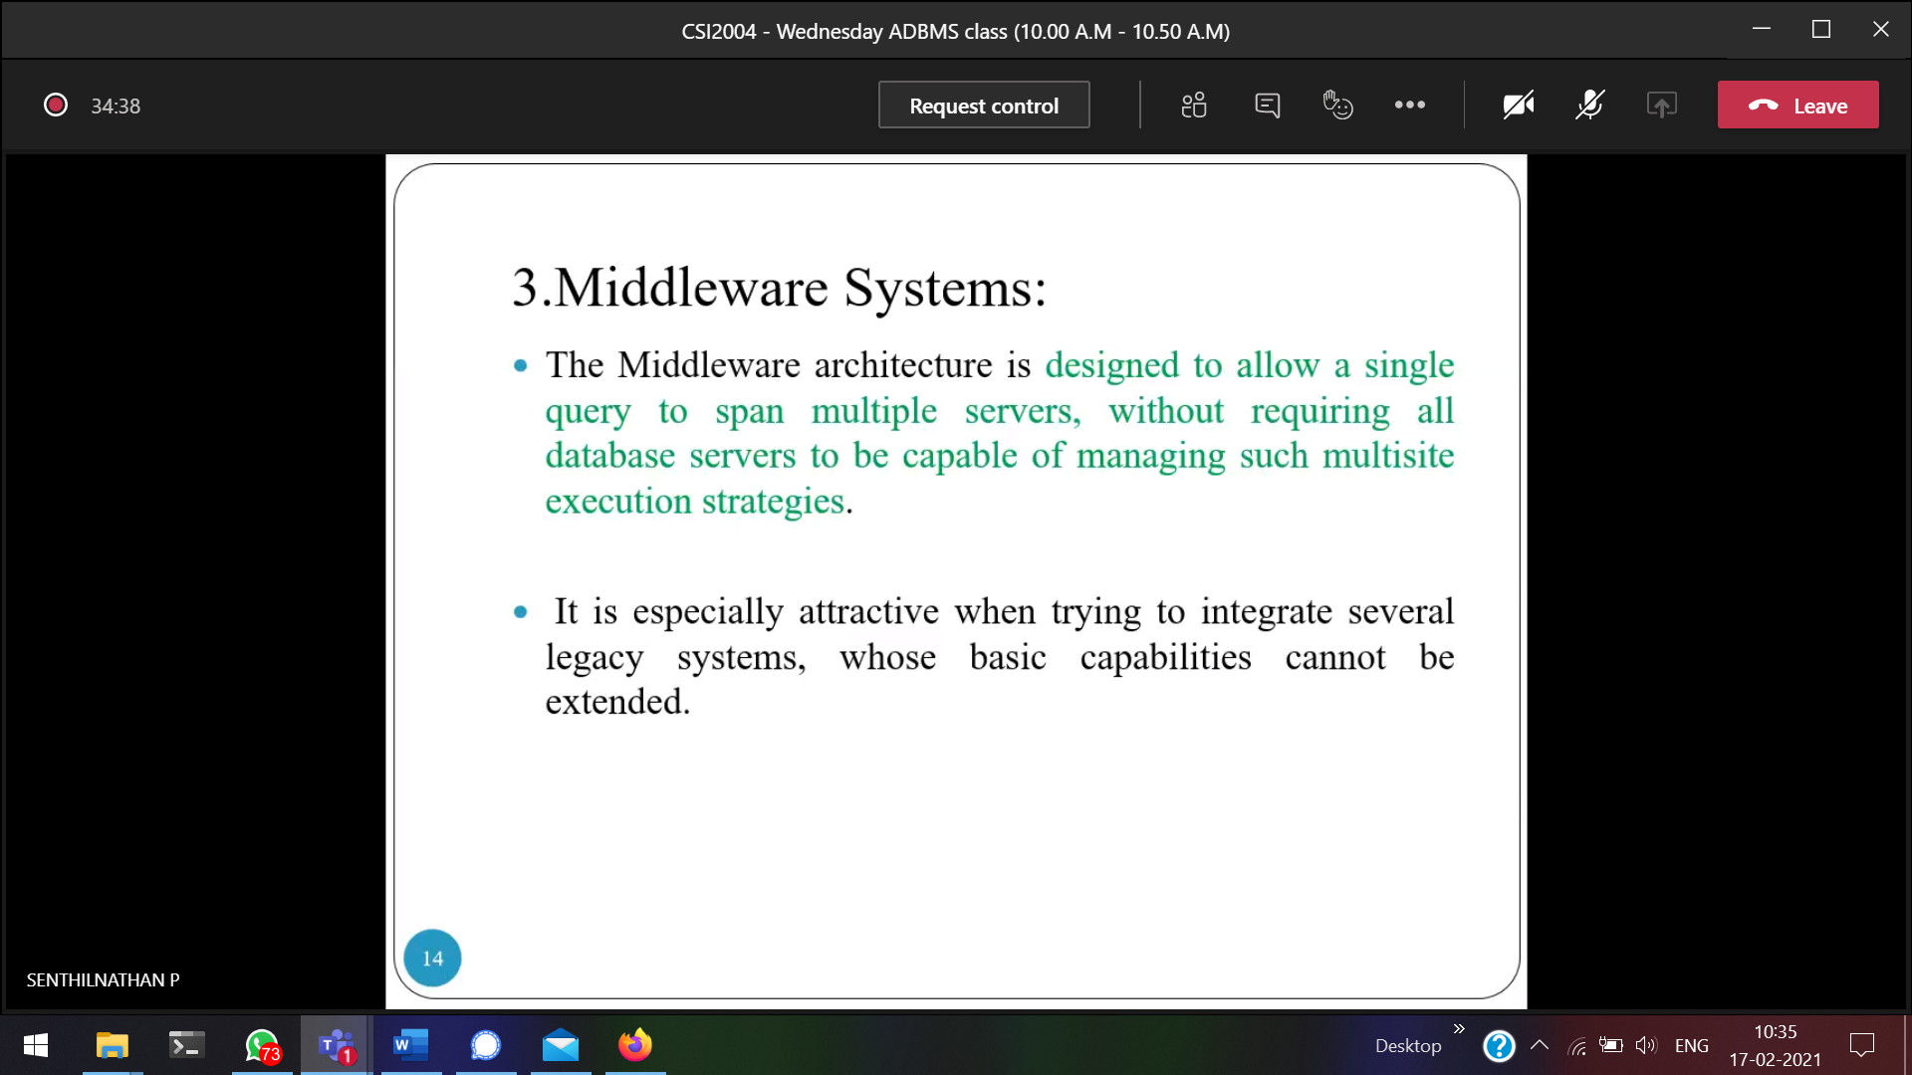  
Does not have capability of having **multi-site execution strategies.**  
Query 🡪 Server-1 , if not pass to server-2, if not pass to server-3 (present) 🡪 Success

DB collaborating and middle-ware systems

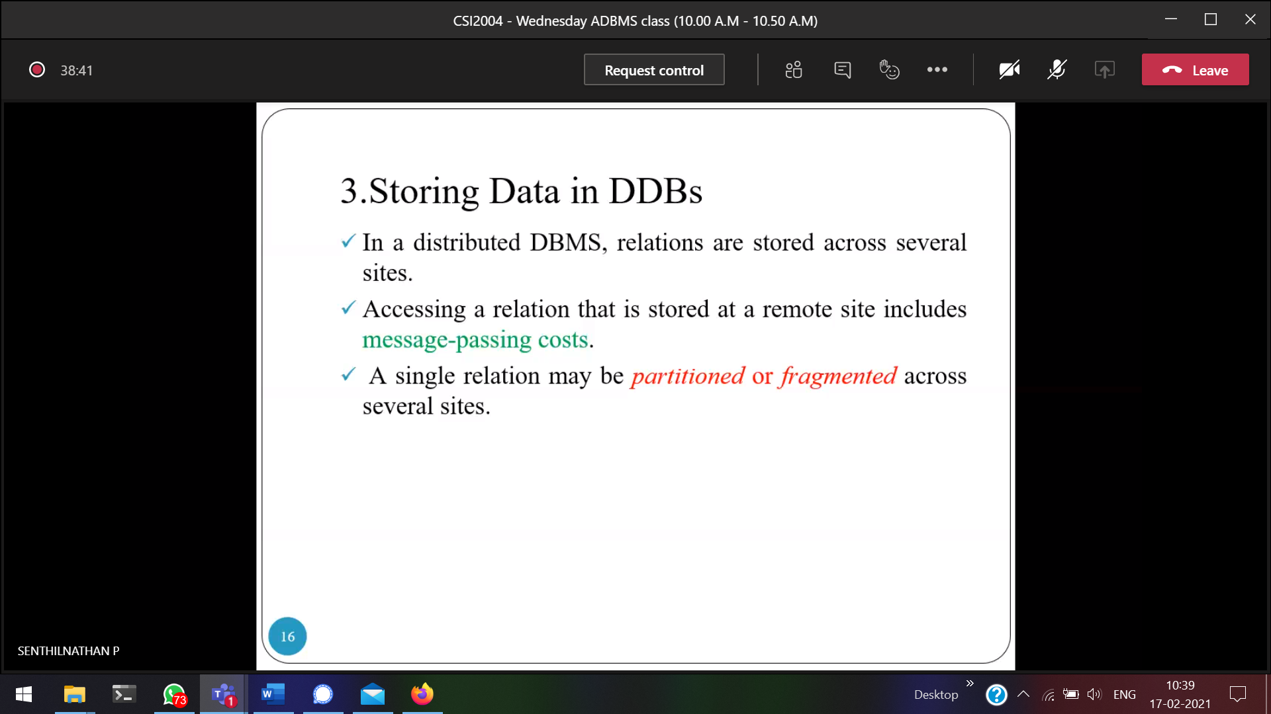



Data will be fragmented and stored in different sites

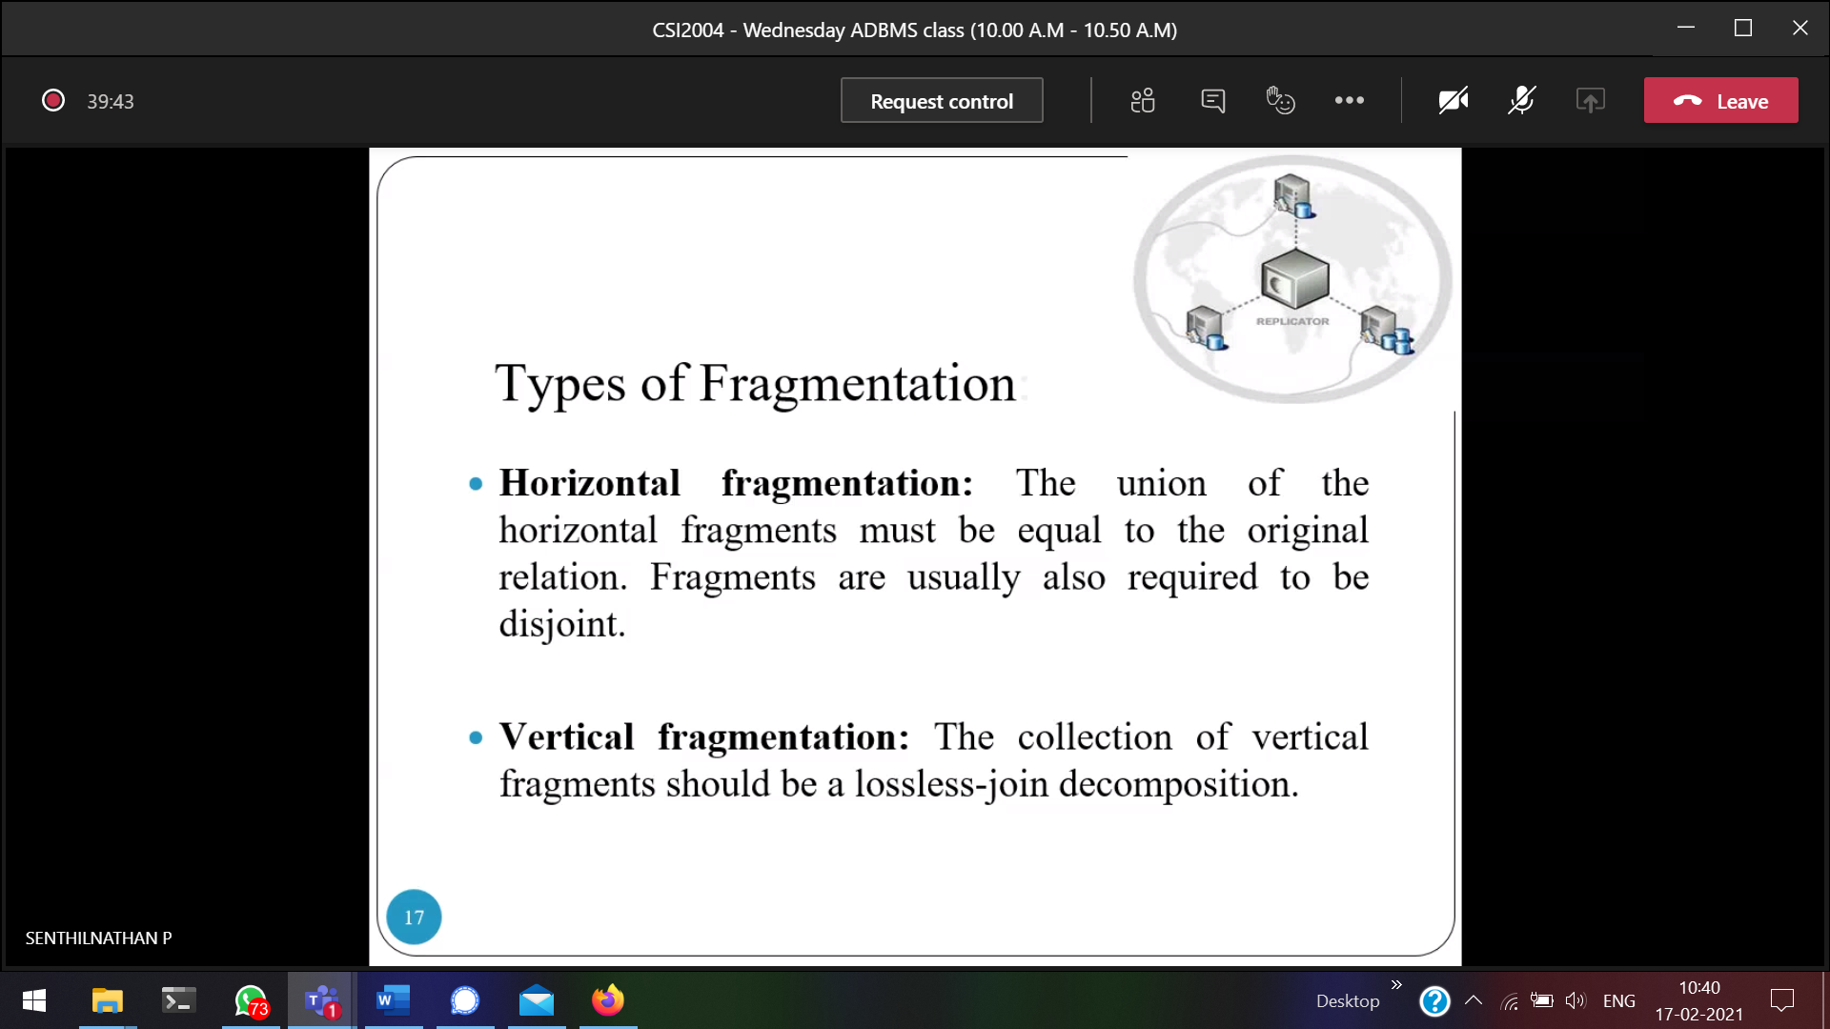



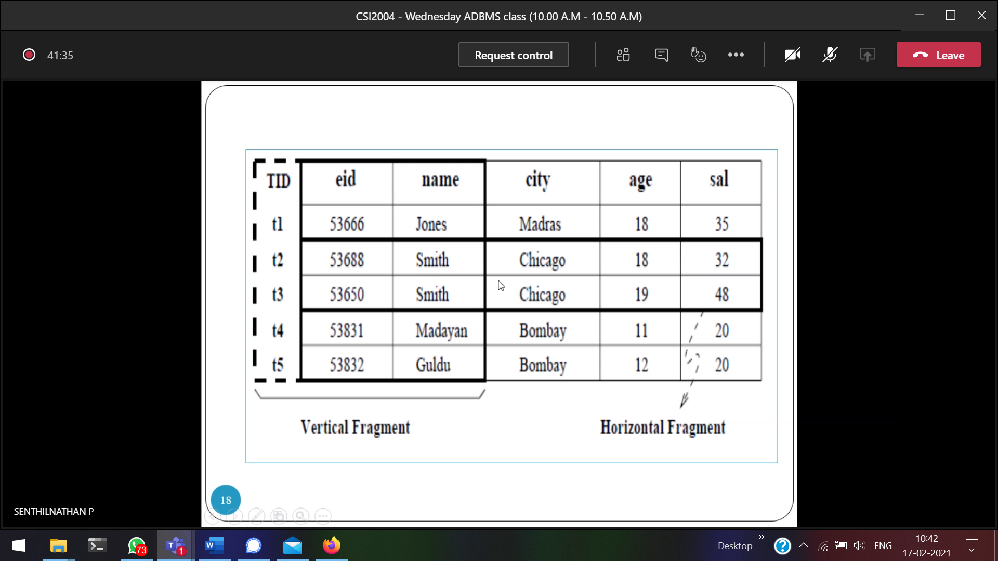  
Only storing Smith related records.

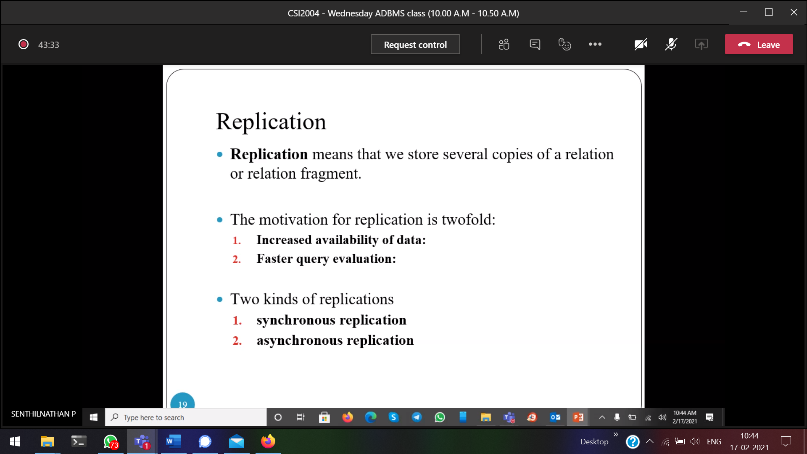

Several copies of the relation in several sites.  
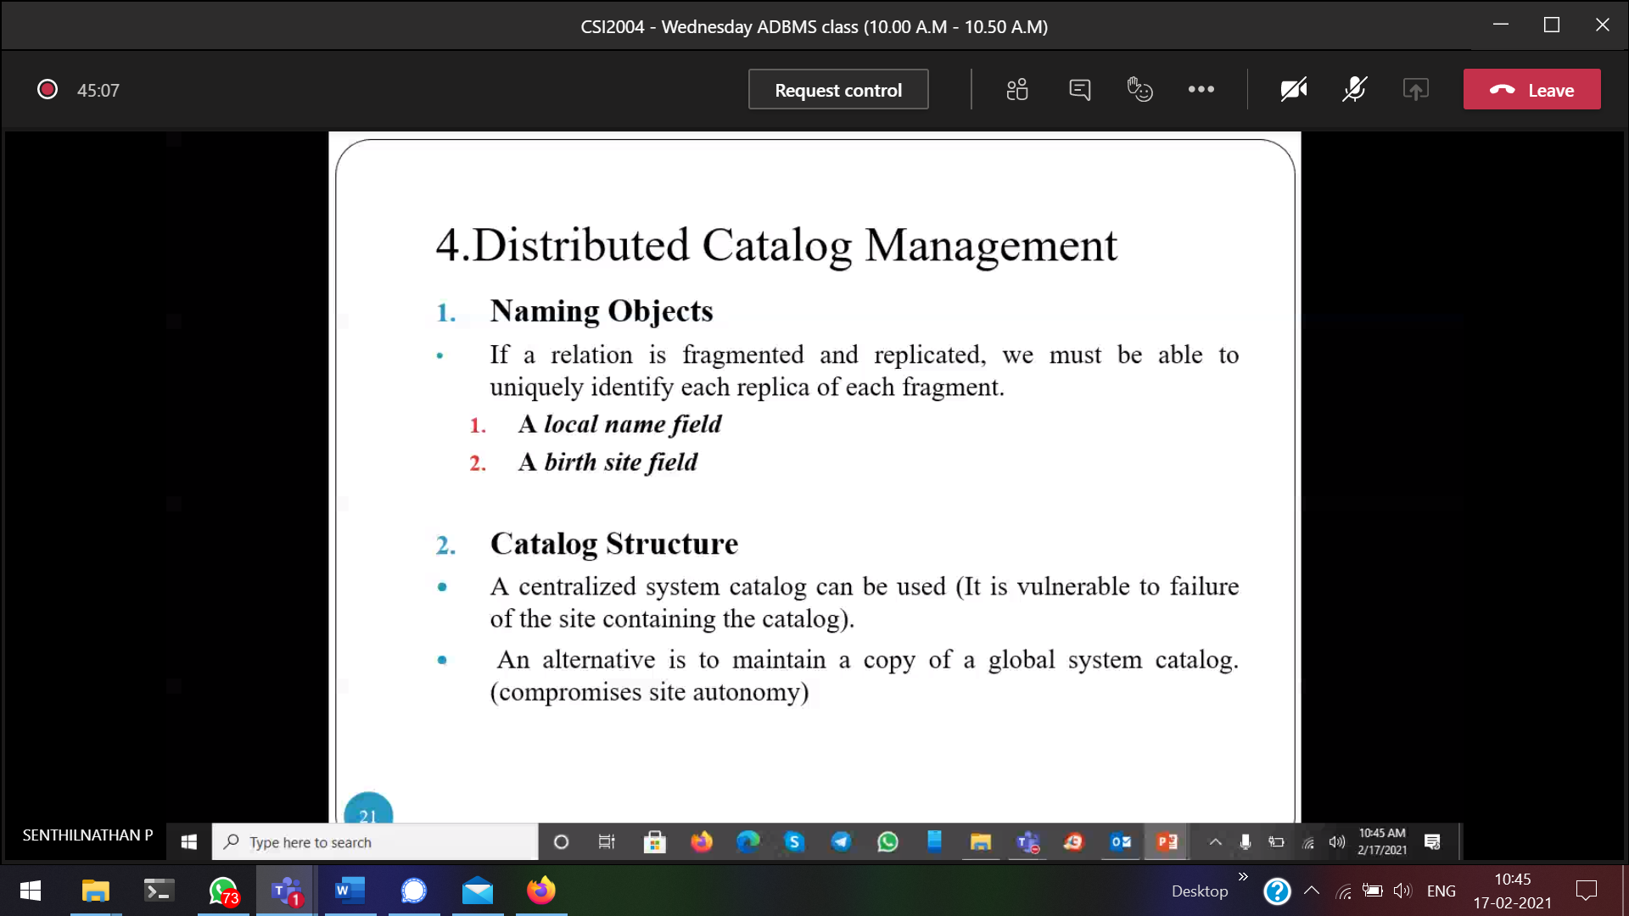

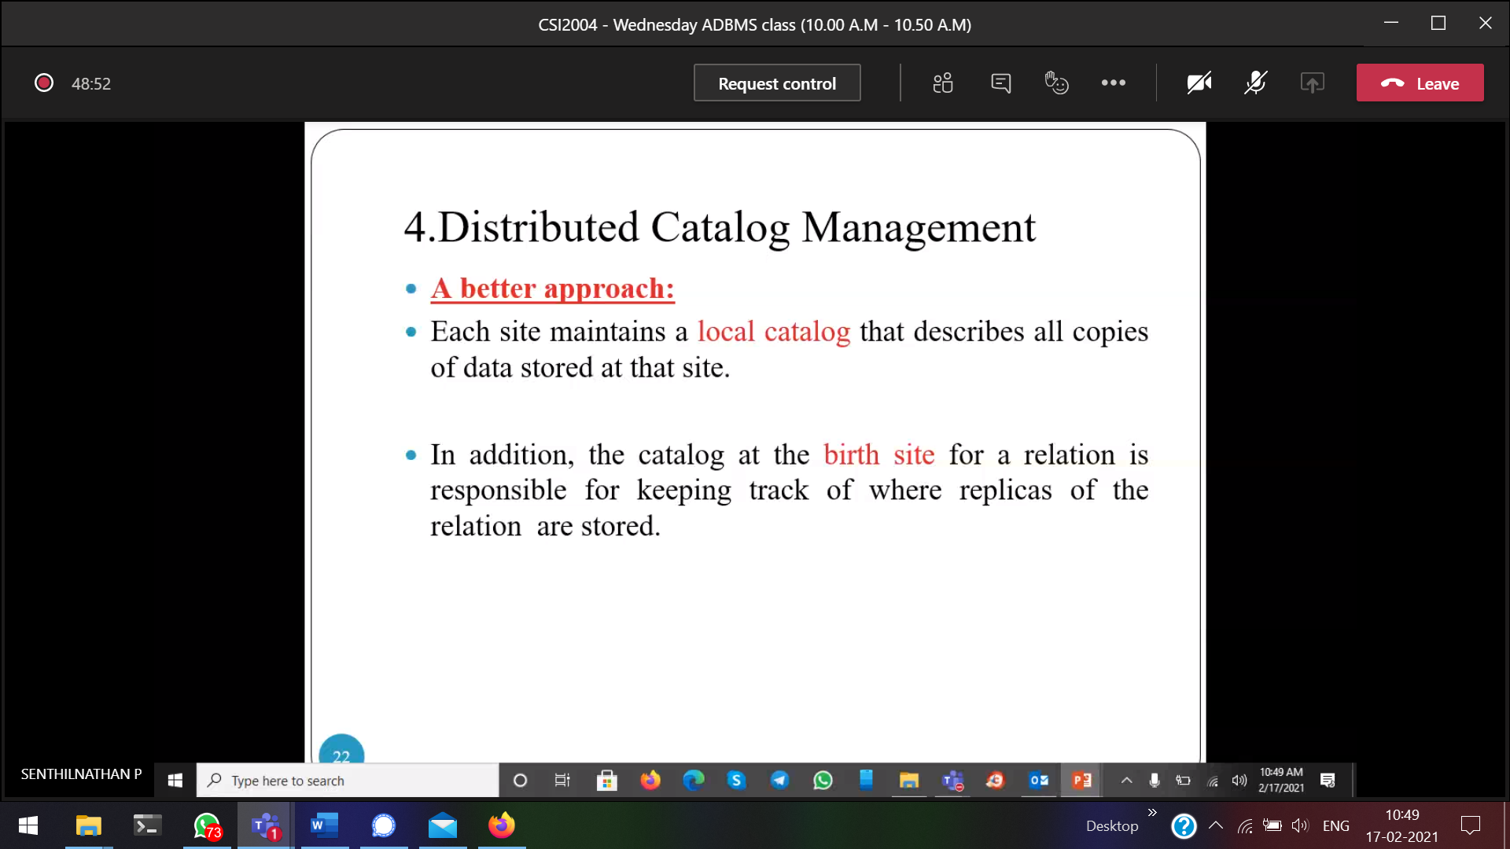

Every site will have a local catalogue. 1 relation copy might be available in n-number of servers

Server-1  
Server-2  
Server-3

19/2/2021

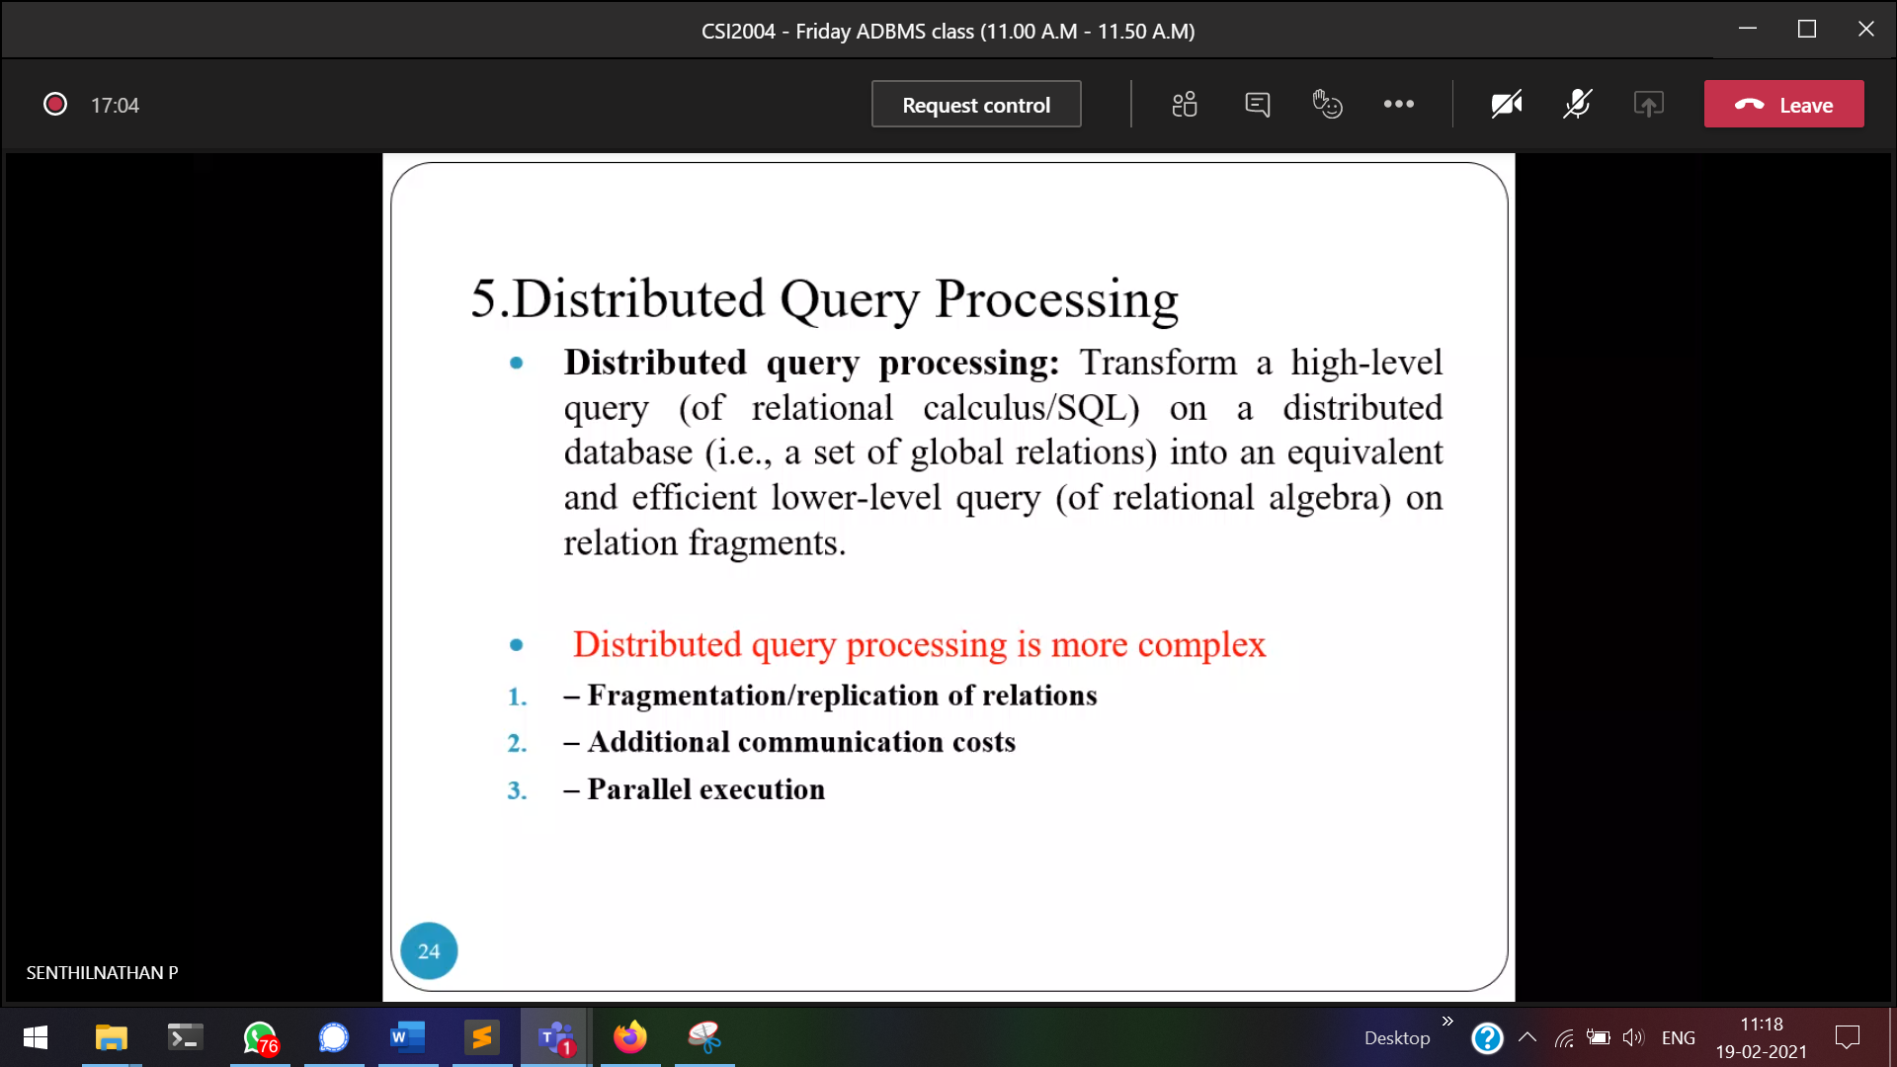

Converting high level query 🡪 low level query

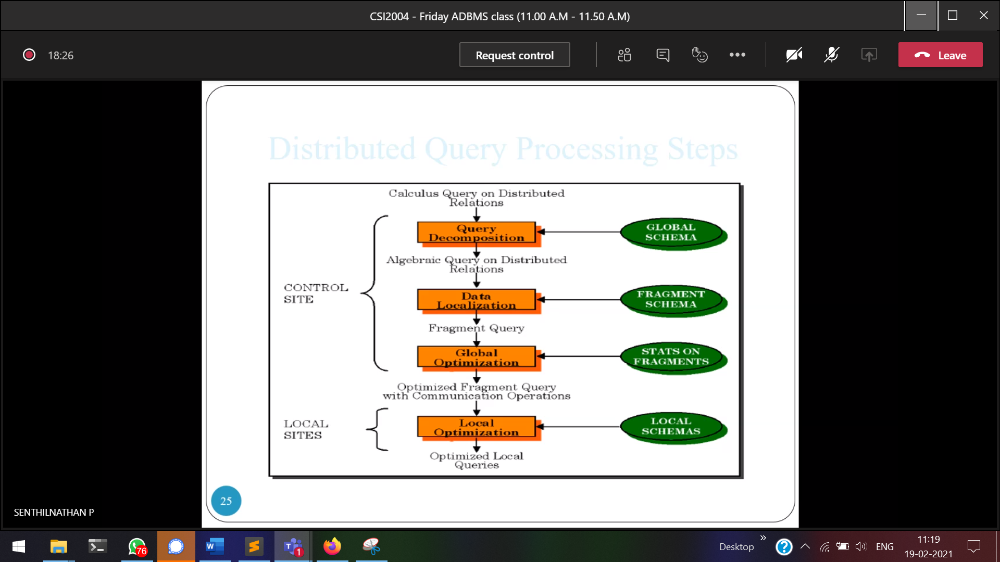



Data localization 🡪 Finding the data

Local schema 🡪 local catalogue

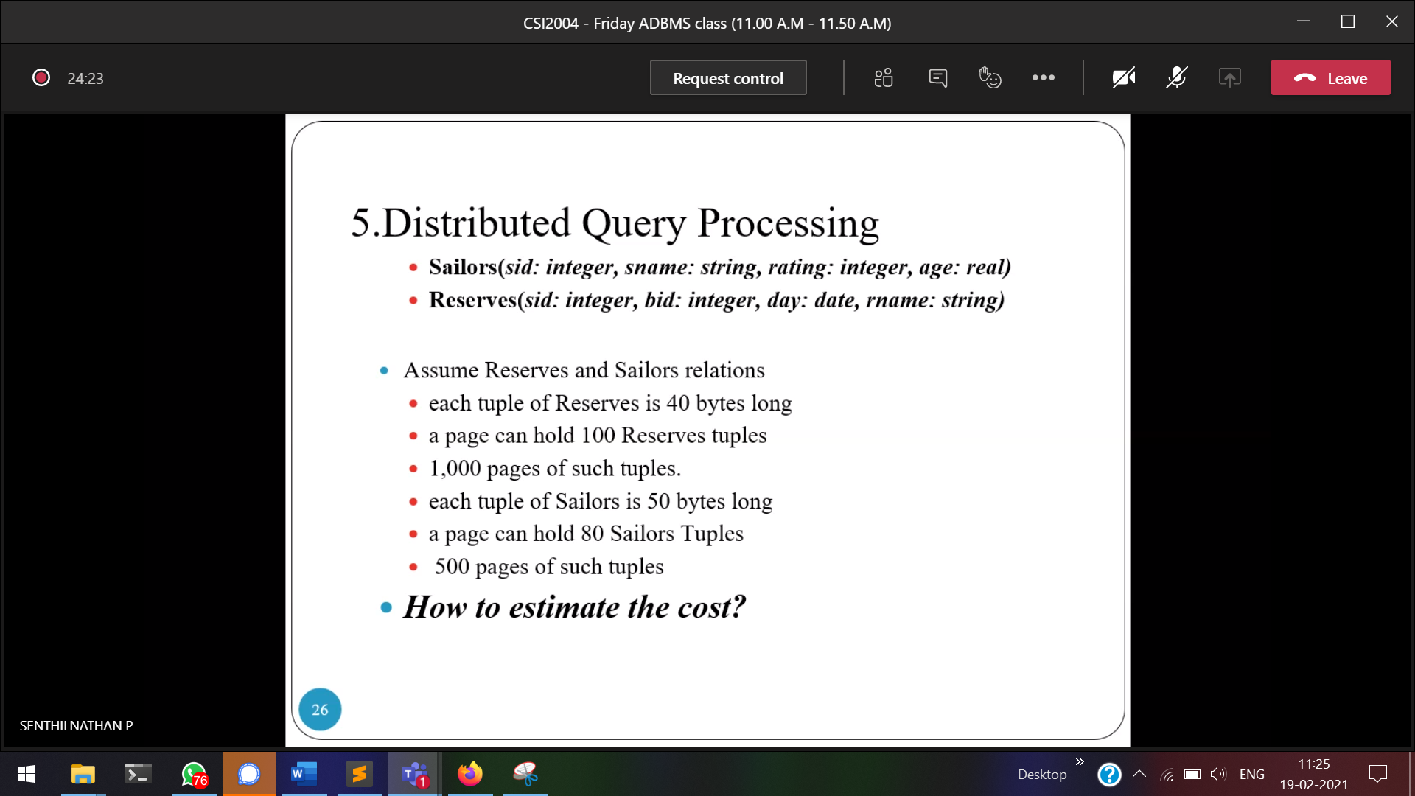

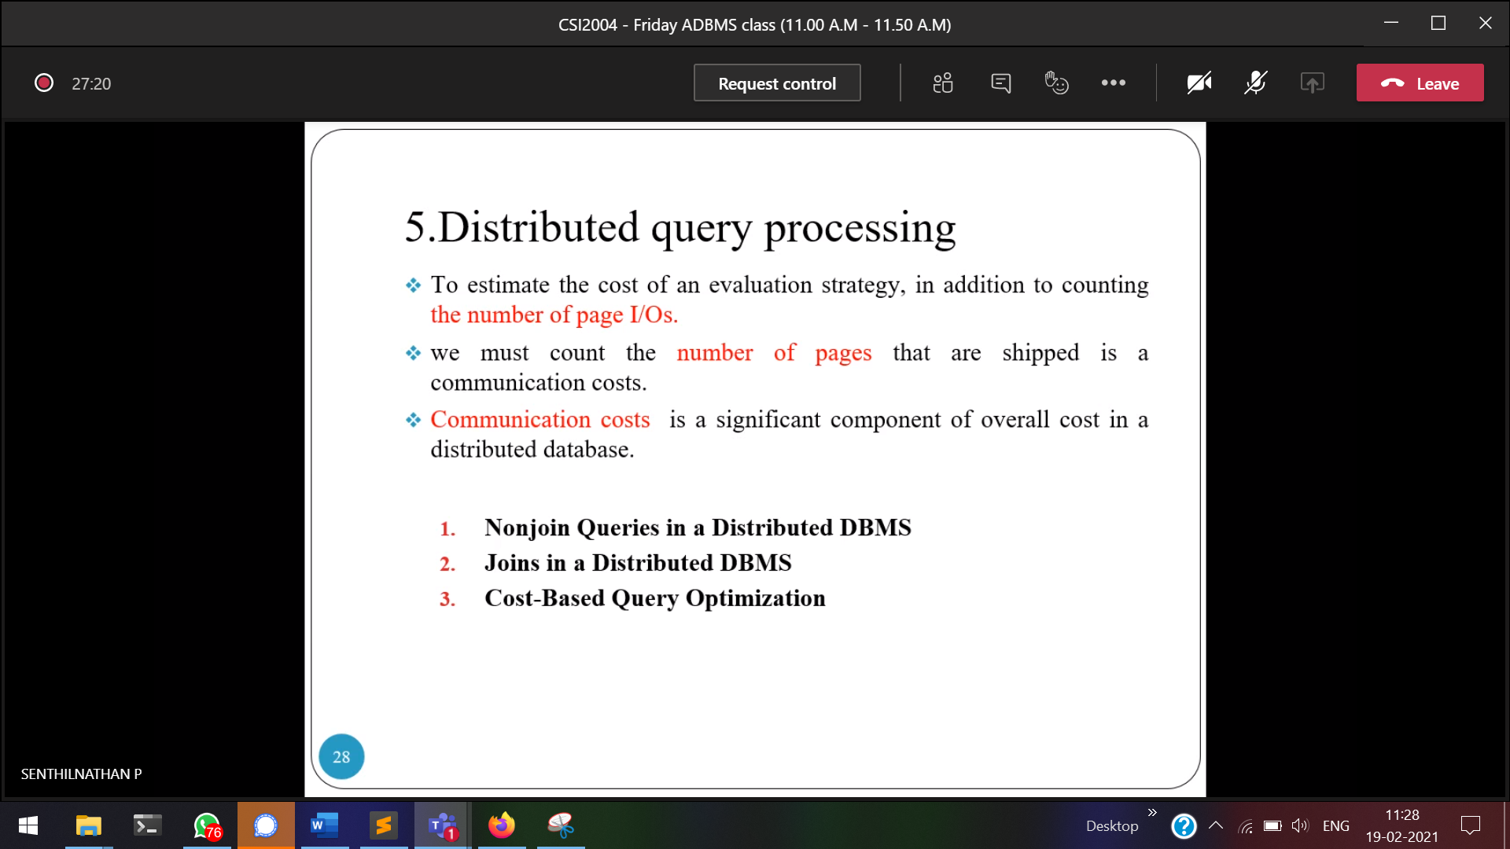

**Horizontal fragmentation**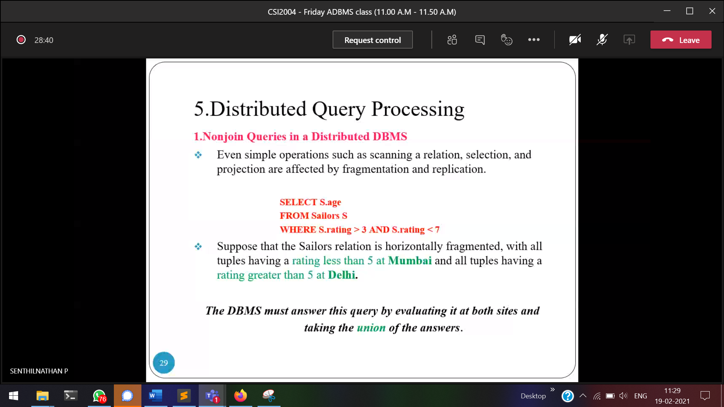  
Sailor’s rating <5 🡪 Mumbai server  
Sailor’s rating >5 🡪 Delhi server

**Vertical fragmentation**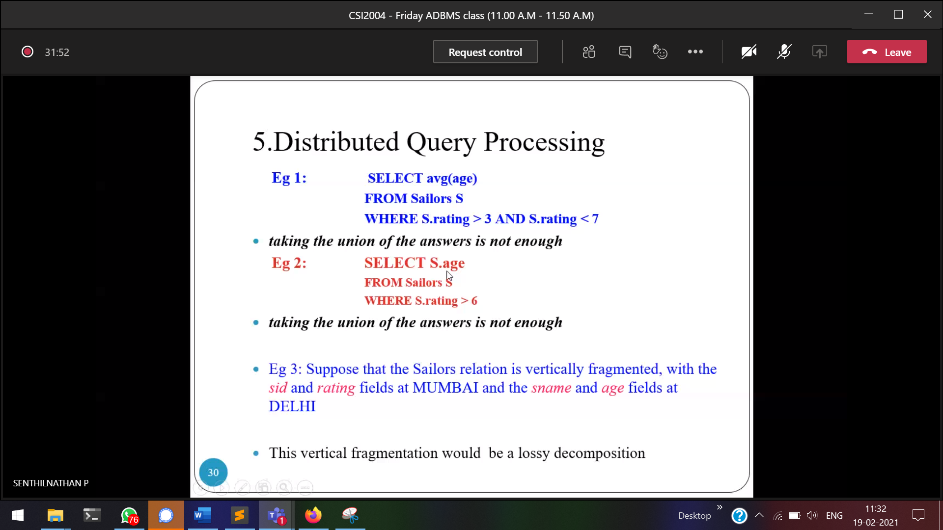  
Apply the above query in Mumbai, get their respective **sid, then** match that sid with Delhi. But sid is not in delhi, and we cannot take age from delhi.   
Vertical fragmentation 🡪Lossy decomposition

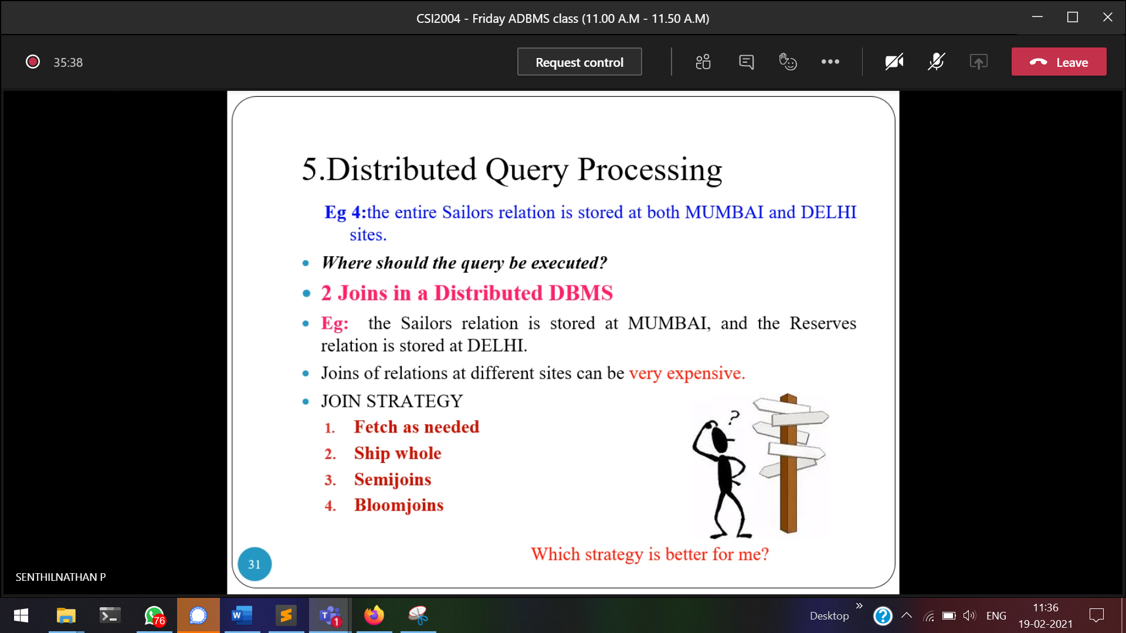

Both the sites reserves, sailor are there. Where to apply the query???

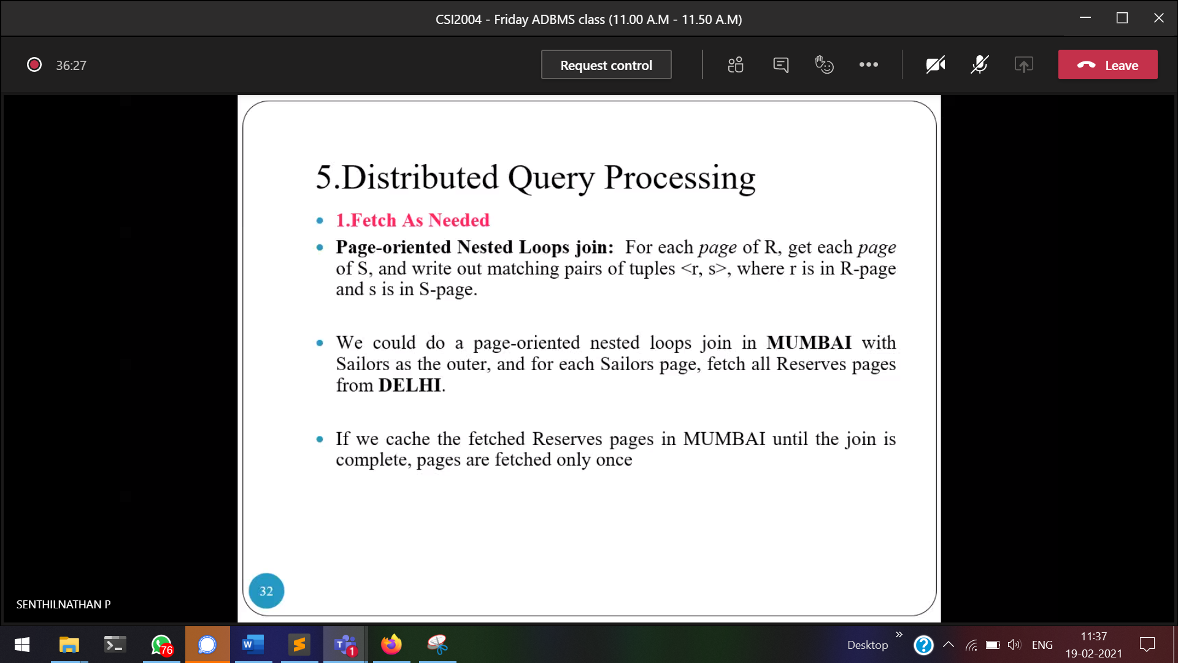

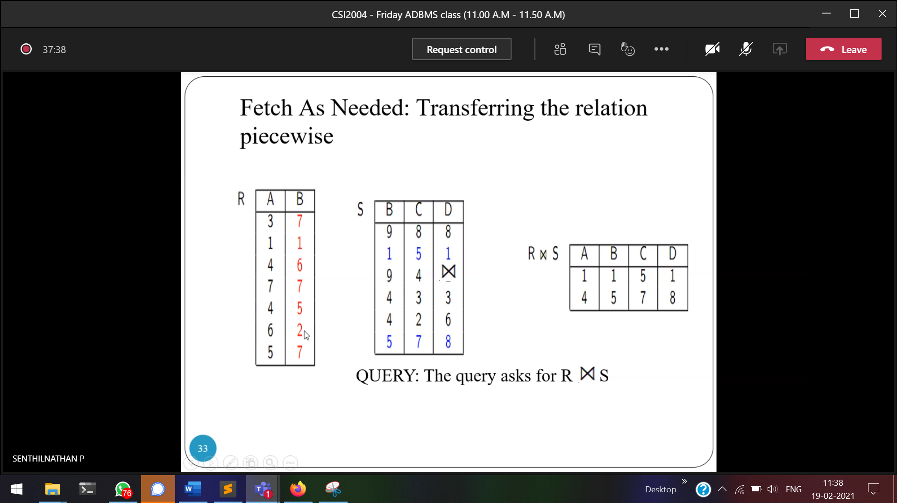

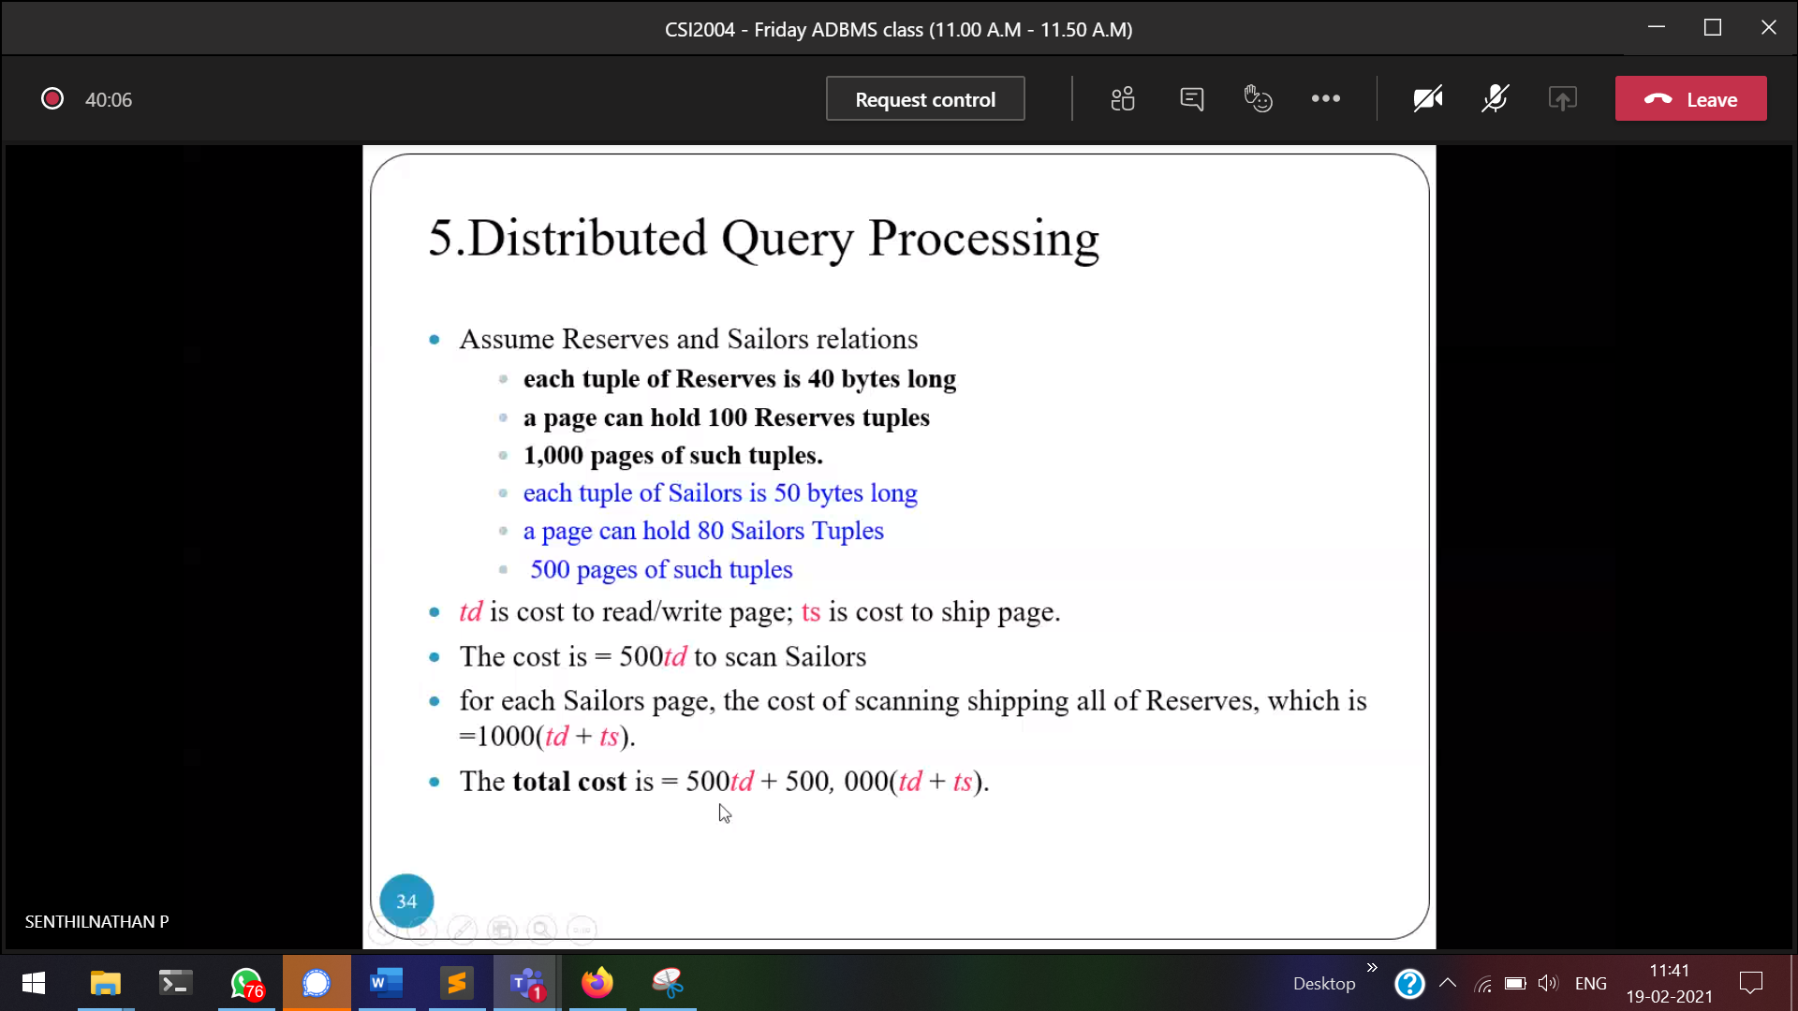

Td 🡪 data transmission cost   
Ts 🡪 ship page cost

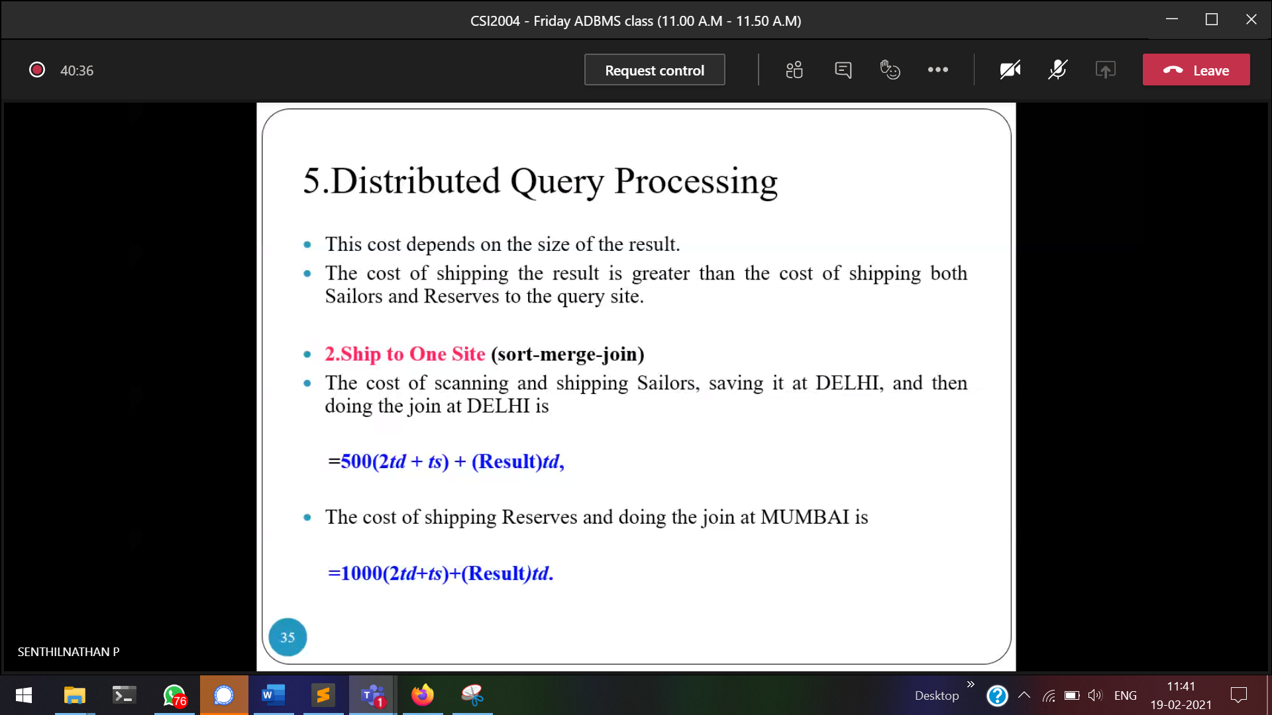  
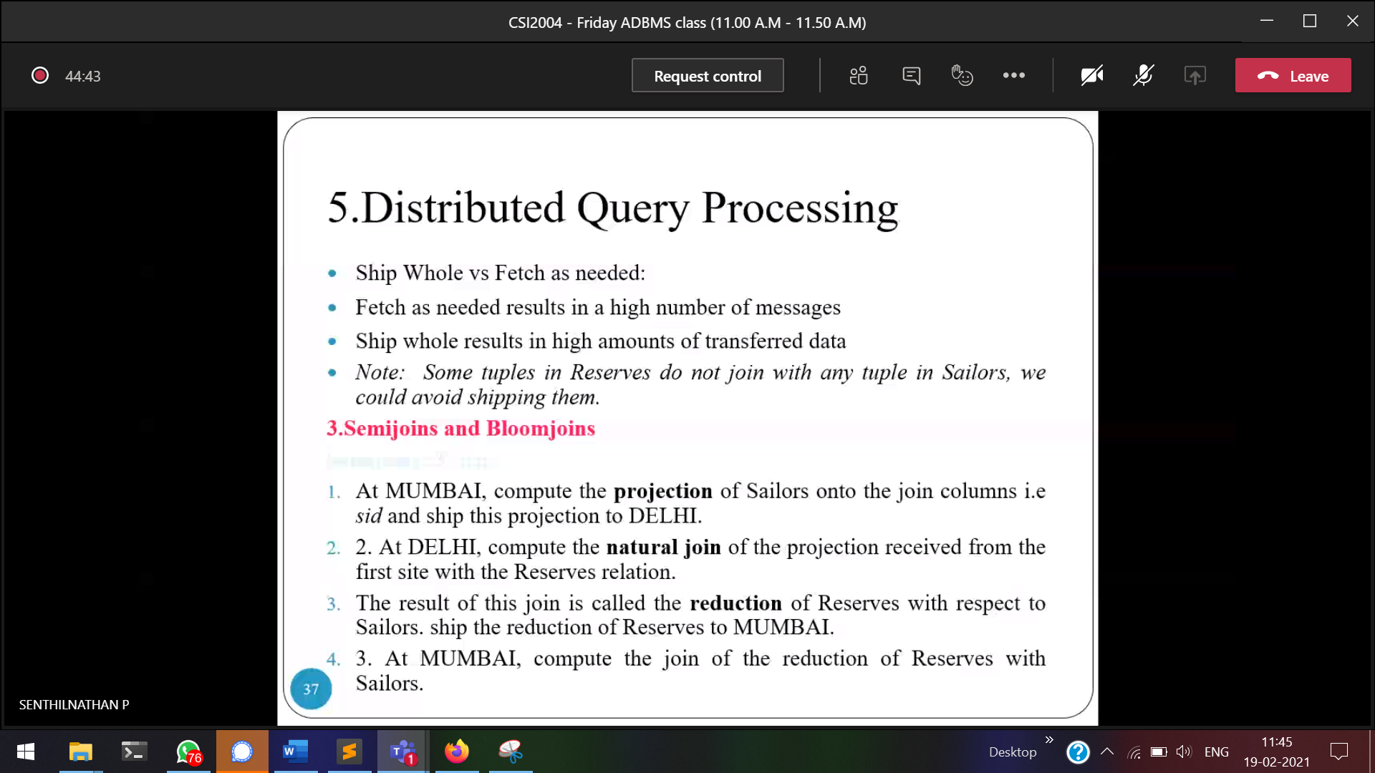

22/02/2021

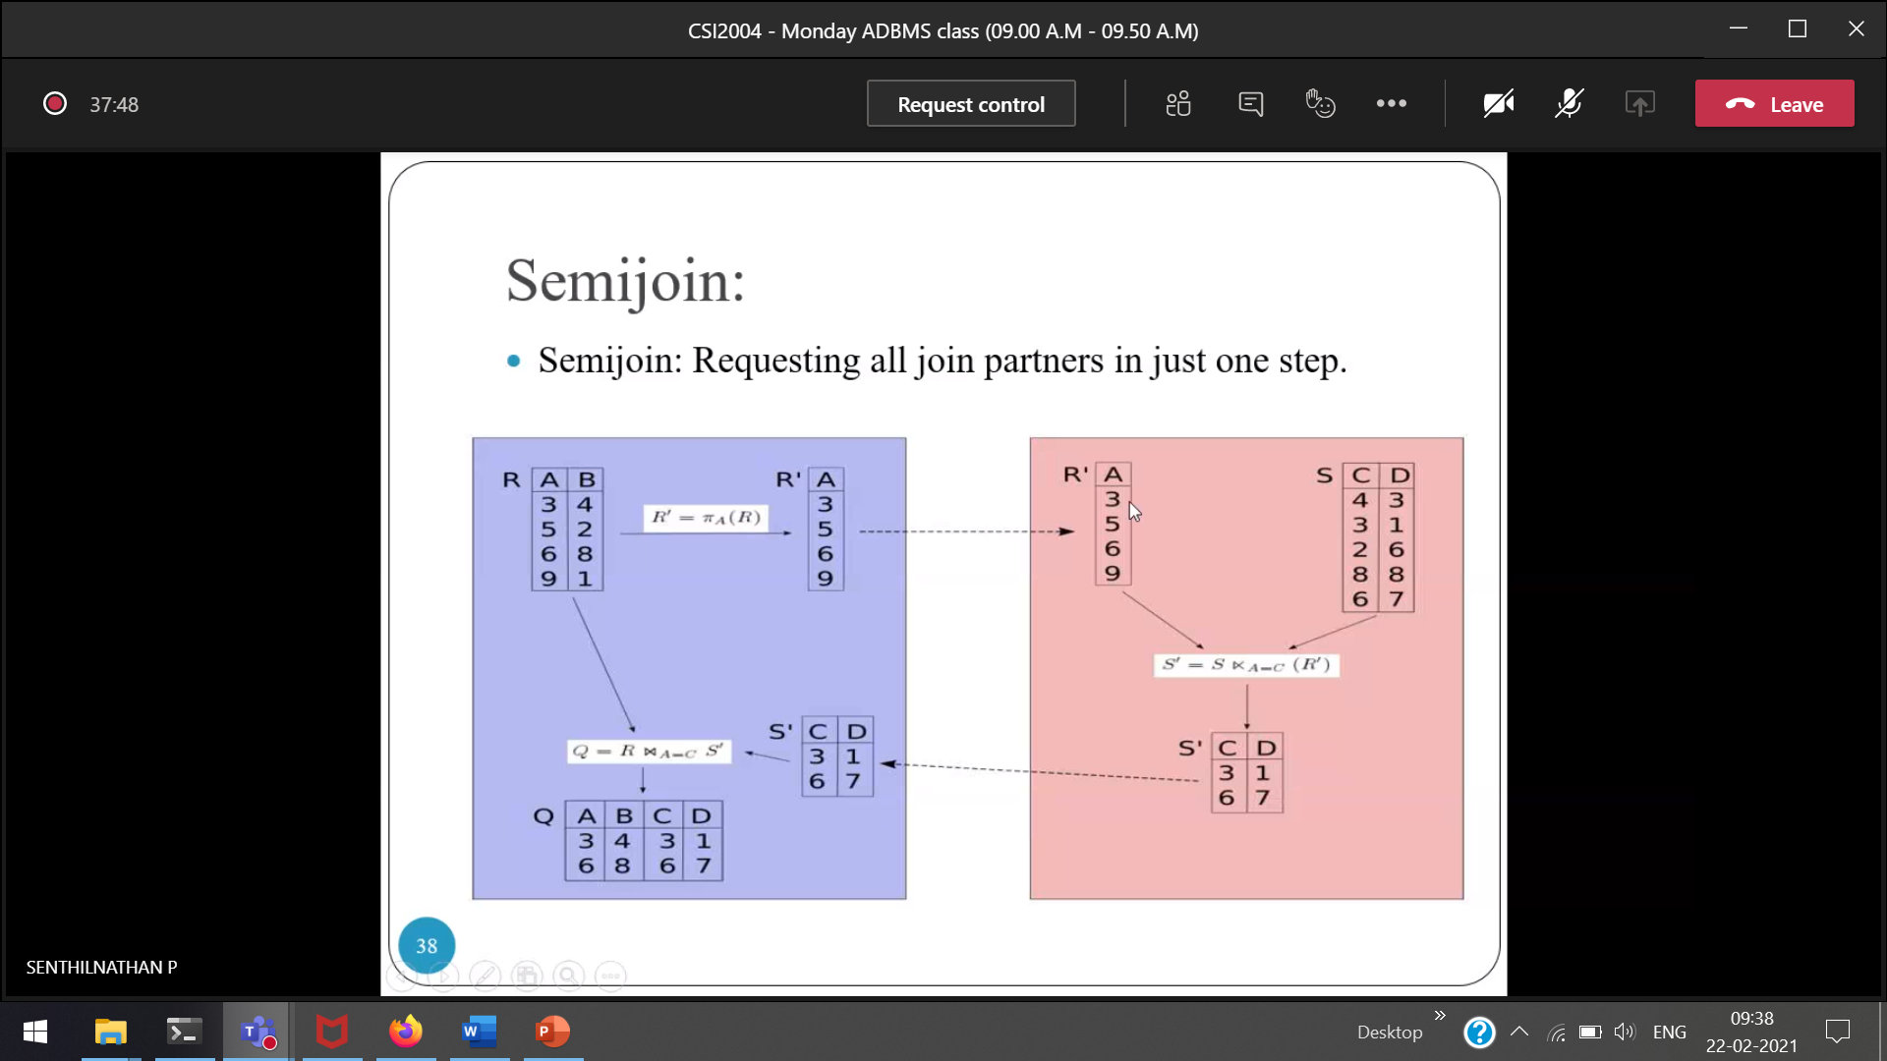  
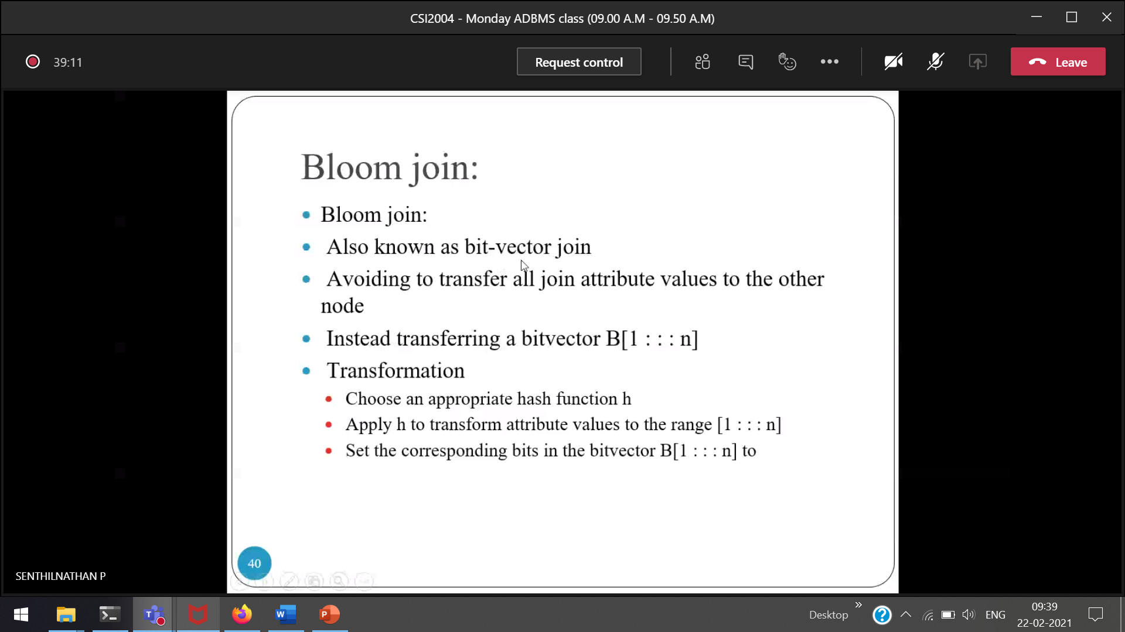



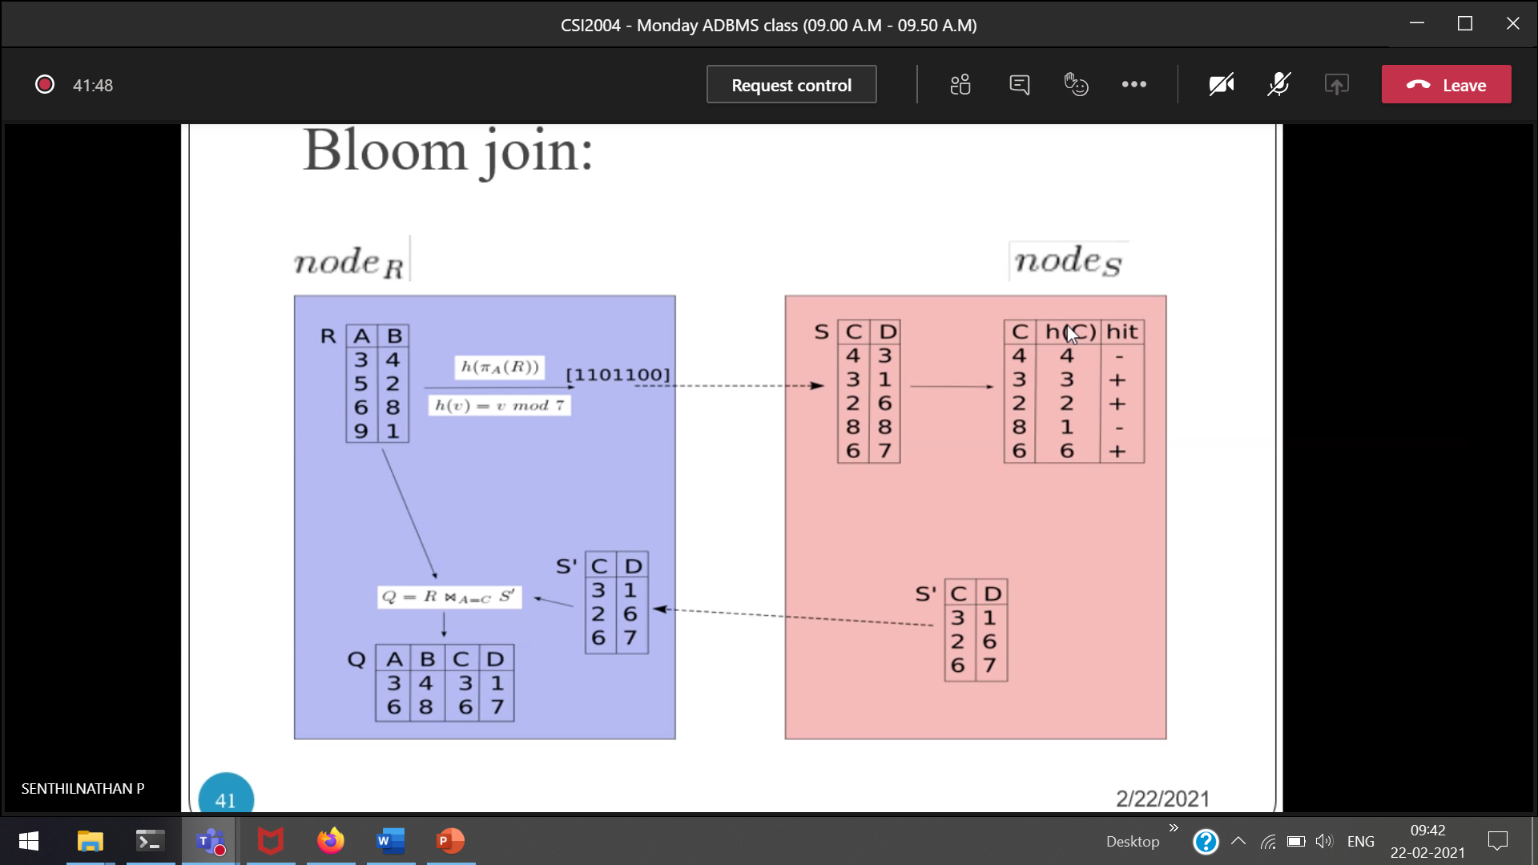

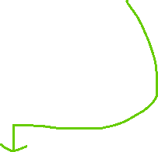

Hashing function

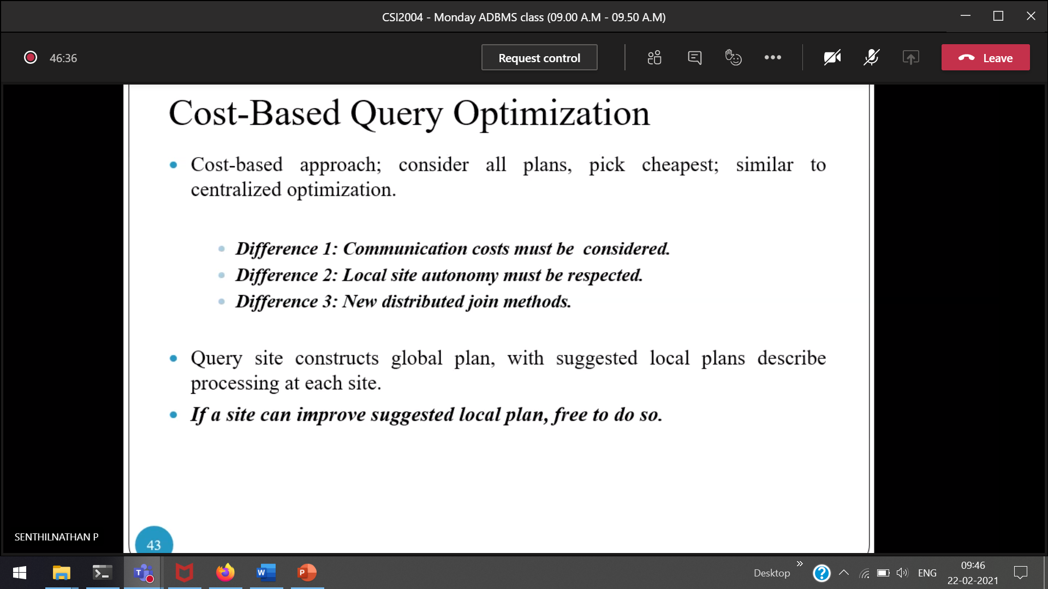  
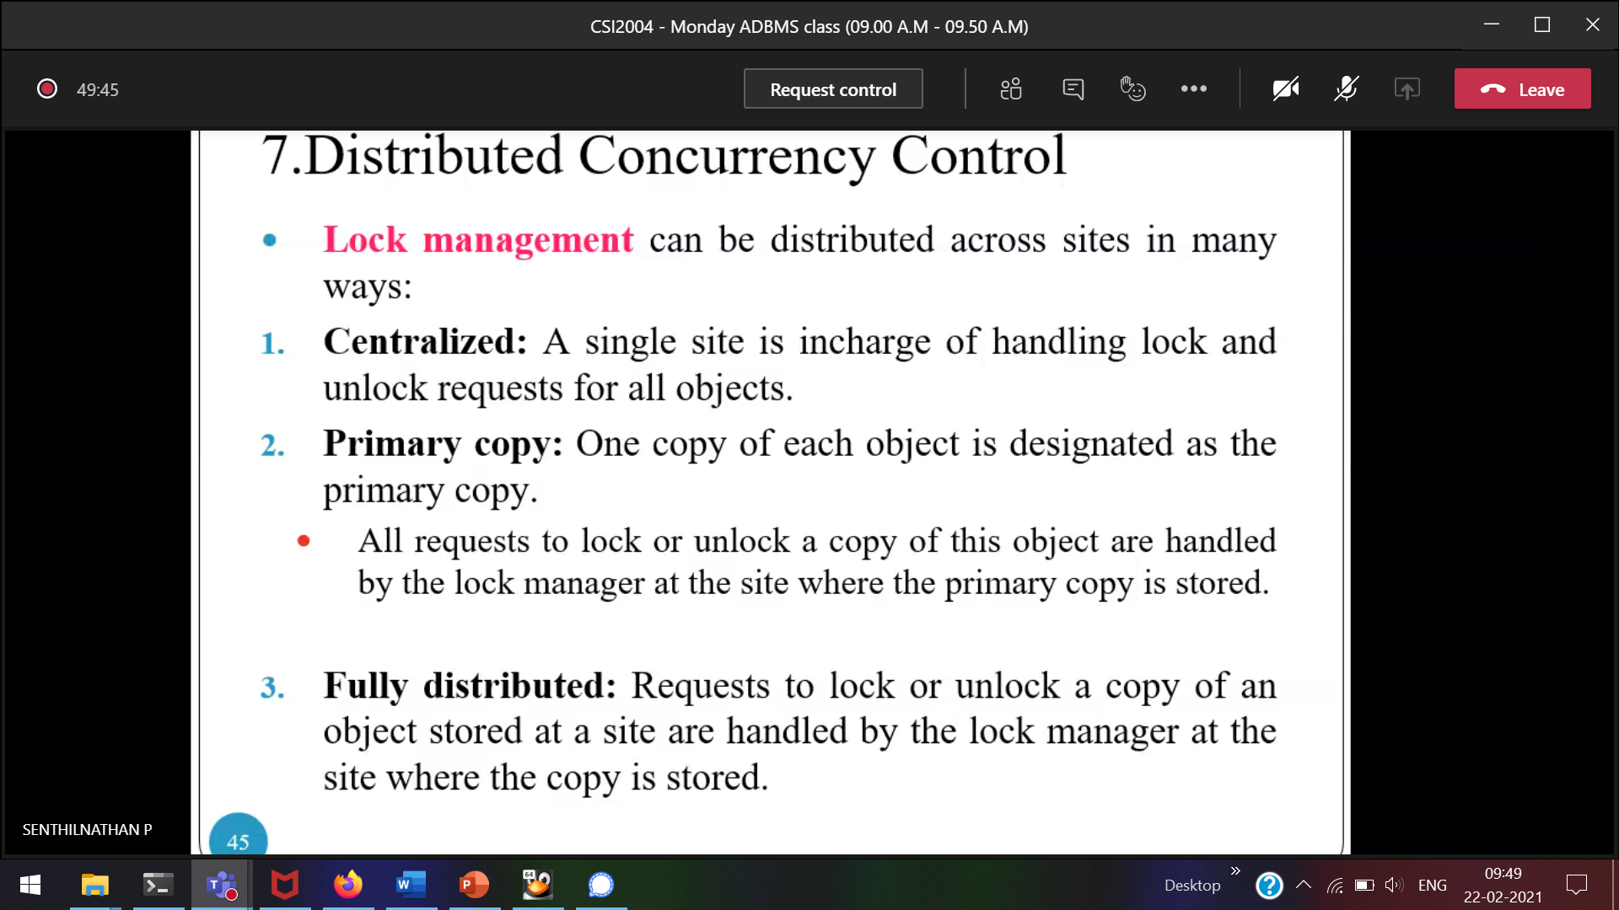  
Every site manager should decide to lock/unlock



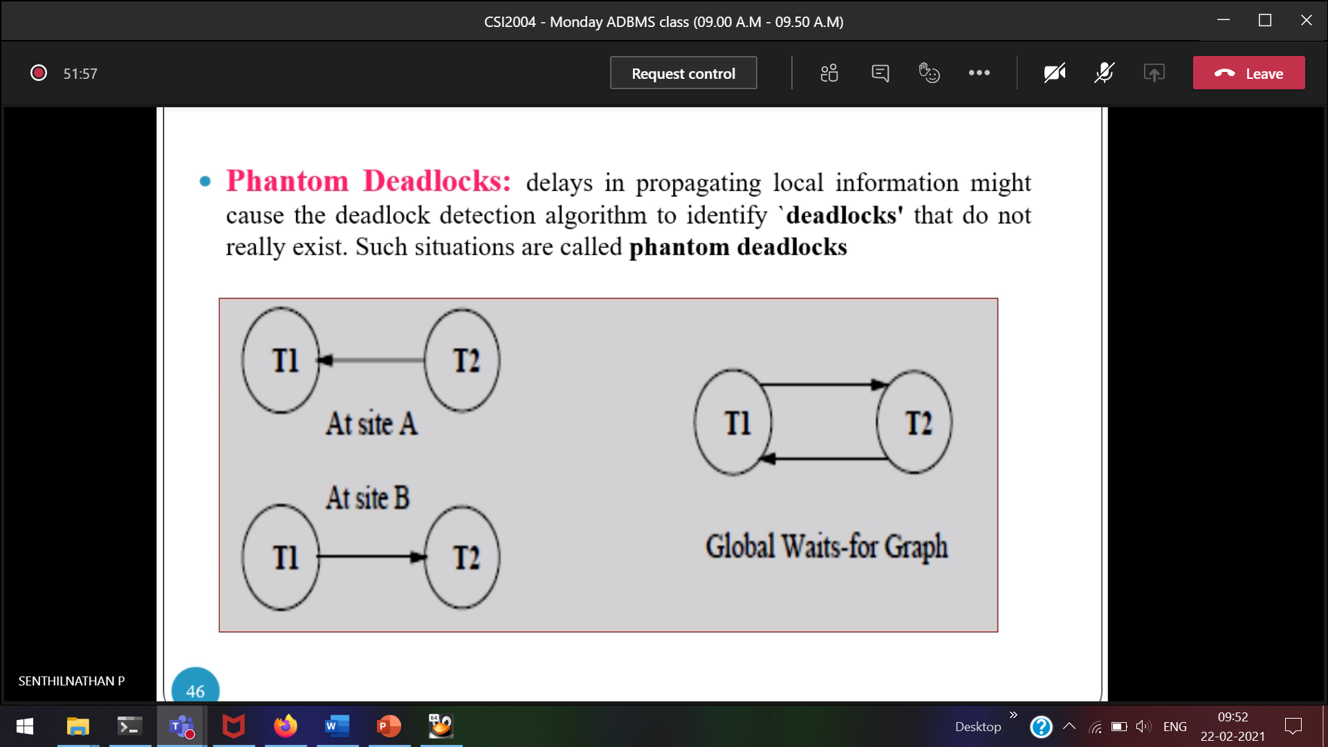  
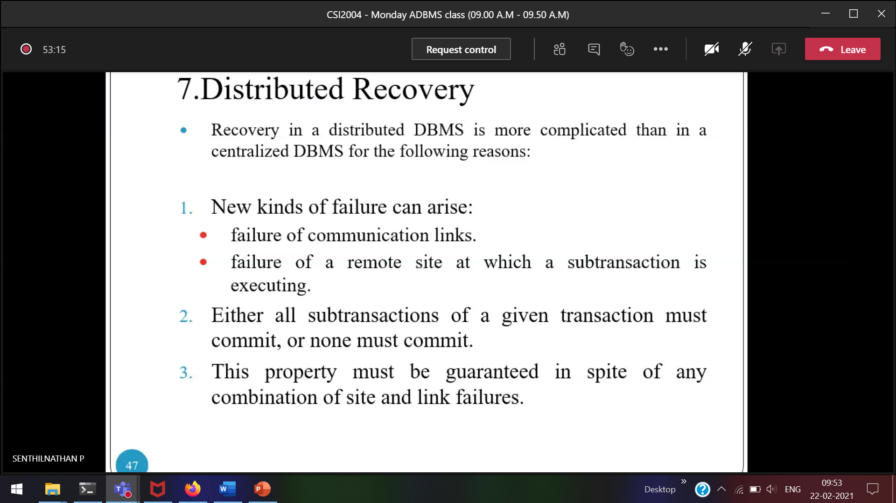

Distributed DBMS Recovery is more tedious than Global DBMS Recovery.  
All the subtractions can be committed/None of the transaction must be committed.

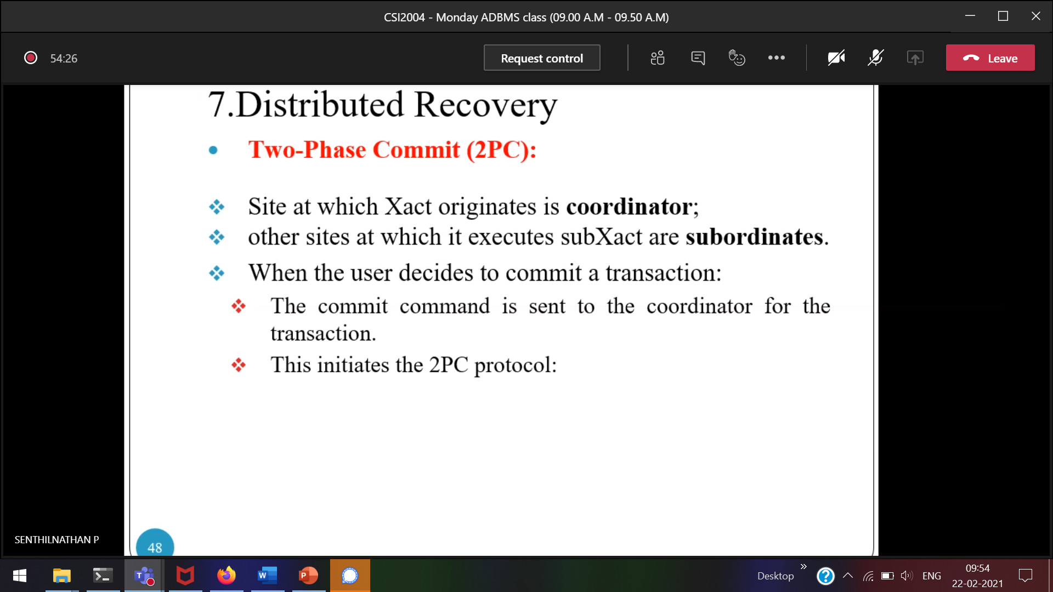

Transaction origin 🡪 coordinator   
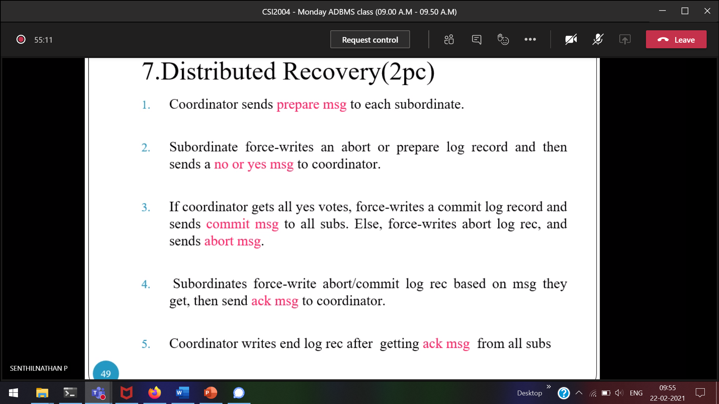  
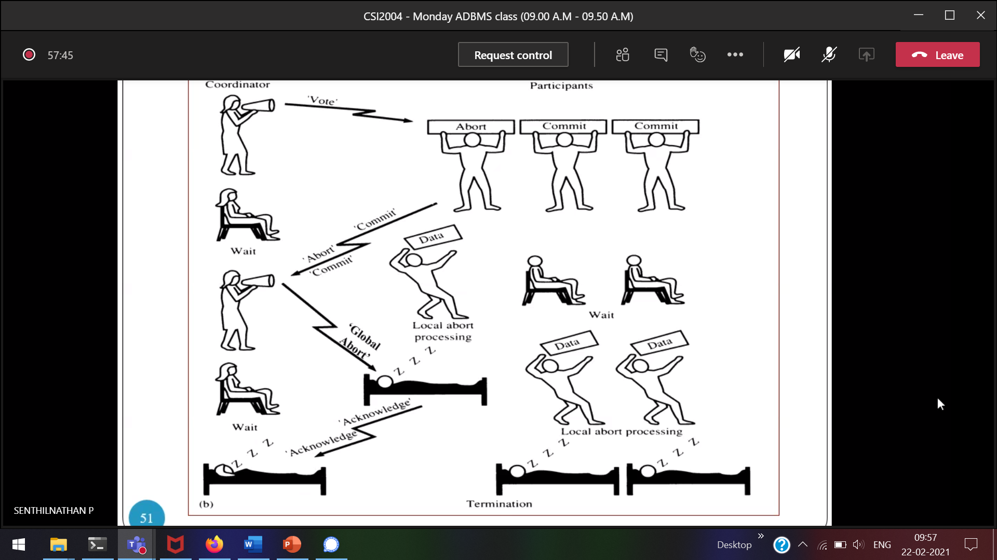

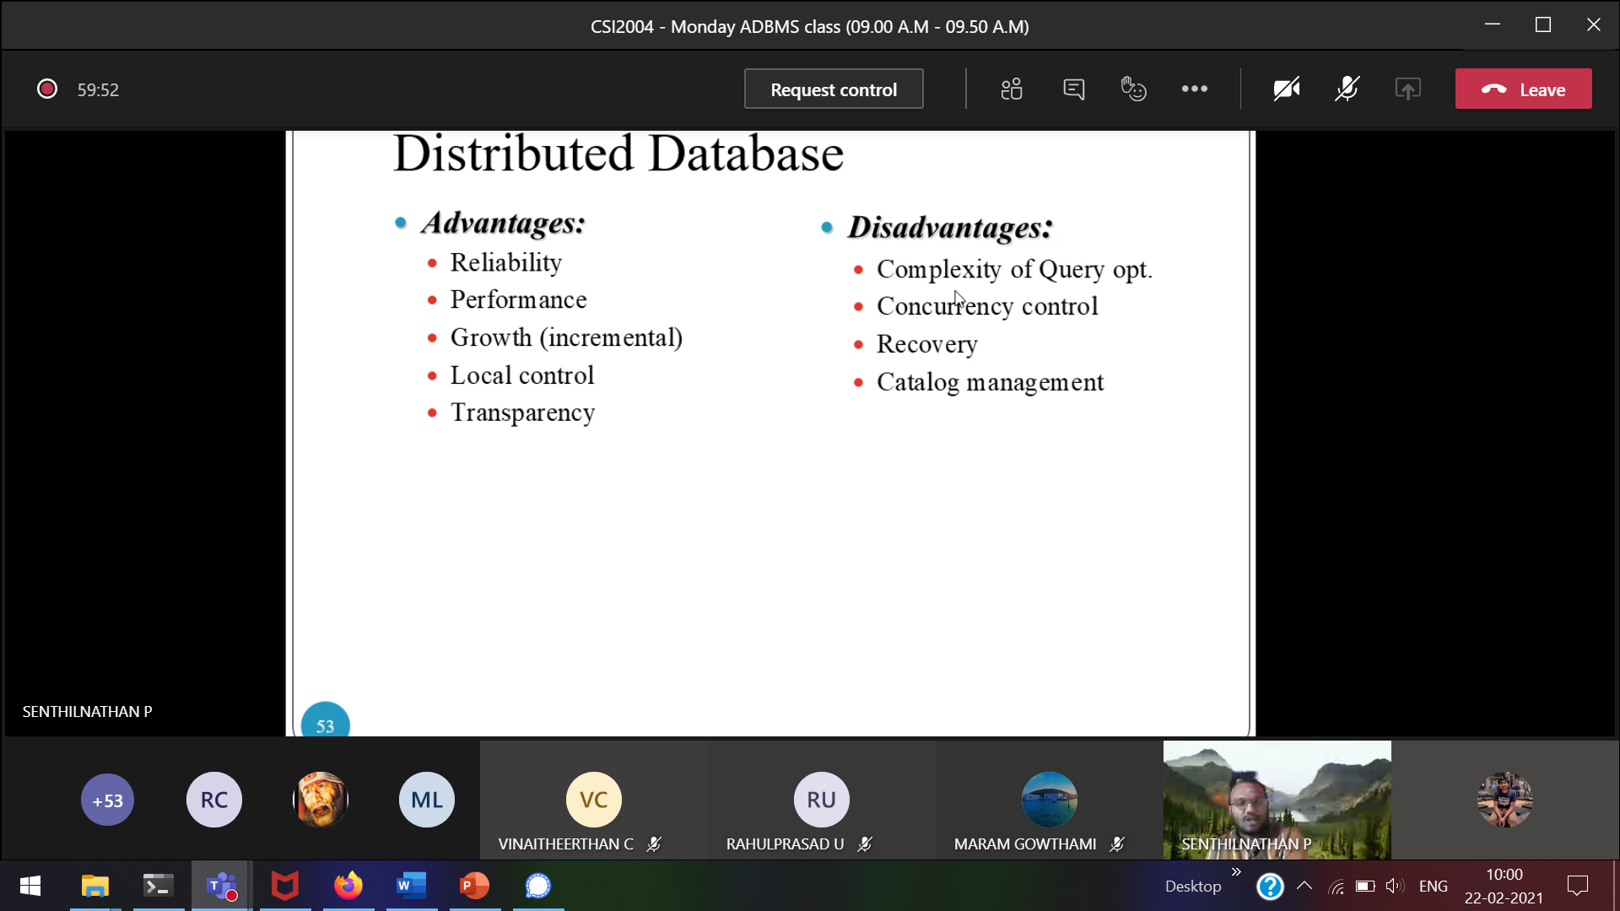

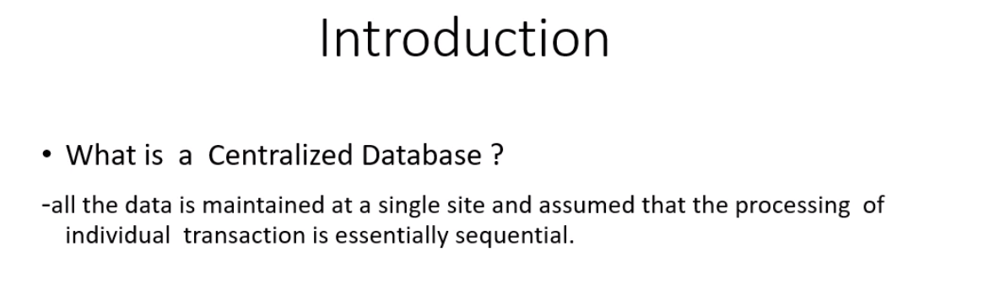  
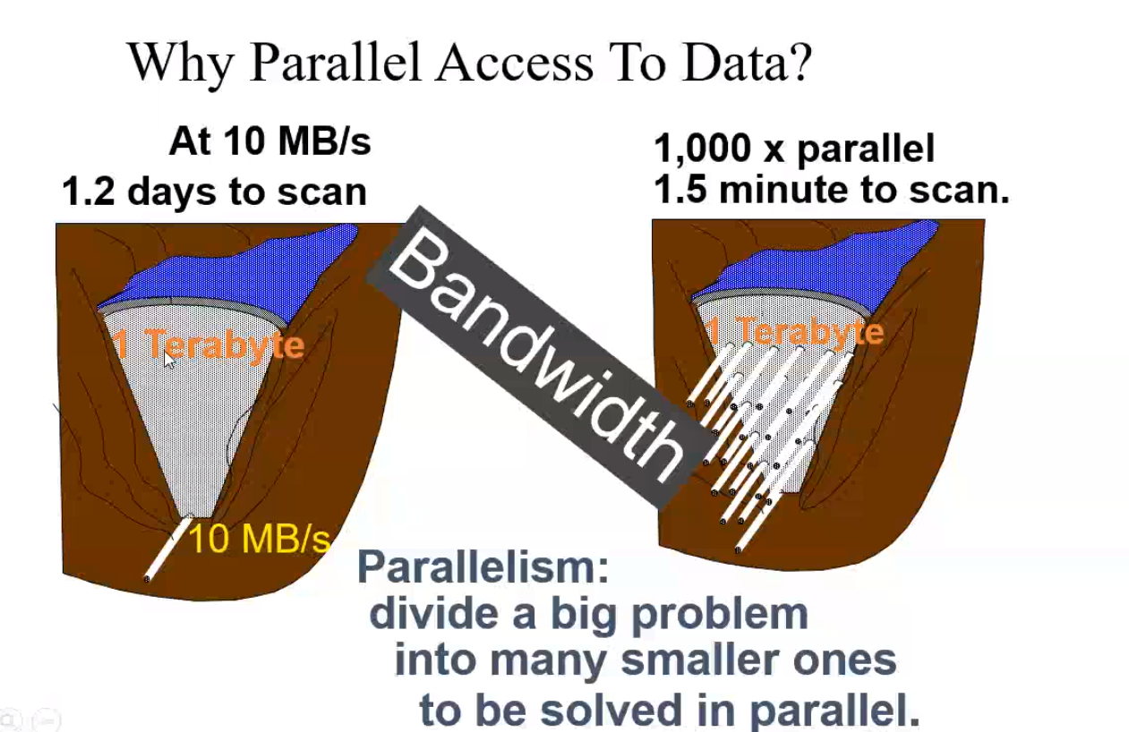

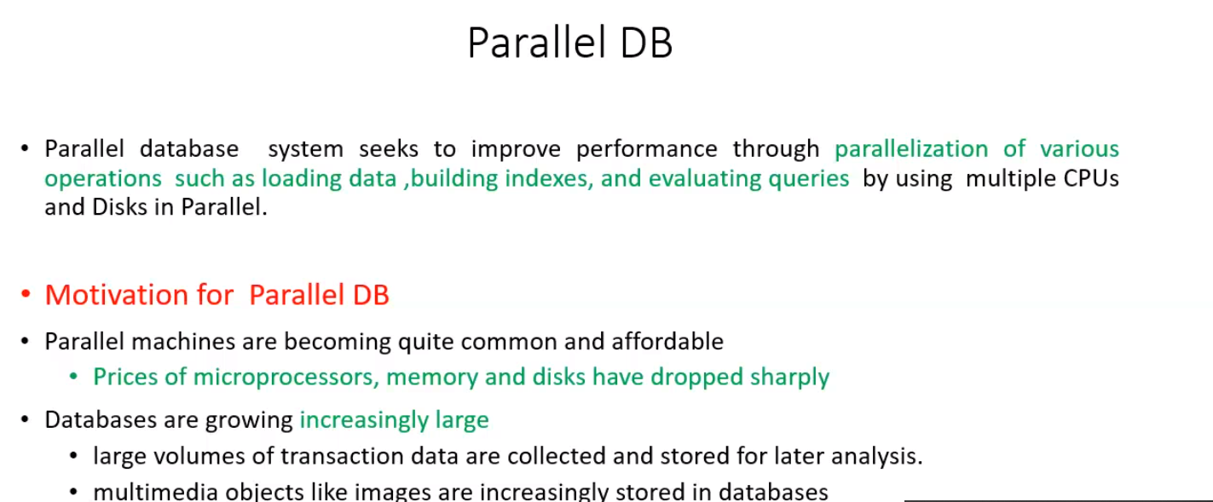



For what parallel DB 🡪 to increase the response time  
How parallel DB works 🡪 By using multiple CPU’s and Disk’s

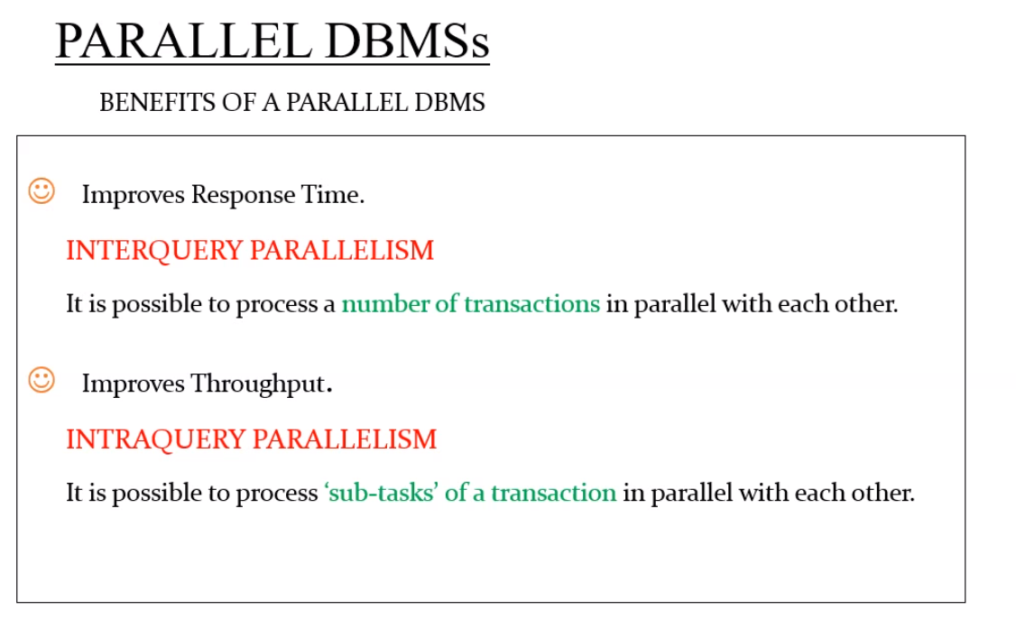



Individual transactions can process parallely.

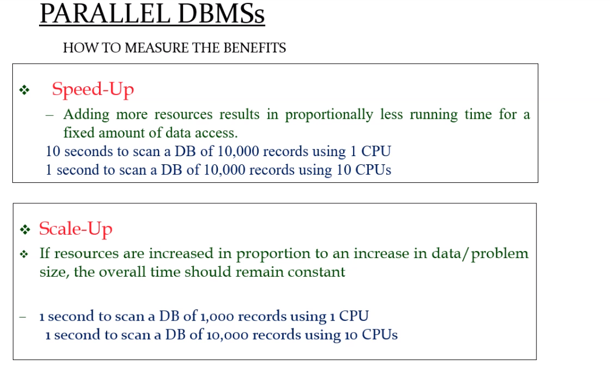



Scale-up 🡪 Access time will remain constant. According to the size of the records, we will increase the resources,

Speed up 🡪 Size of the records will be same, access time is reduced by increasing the resources

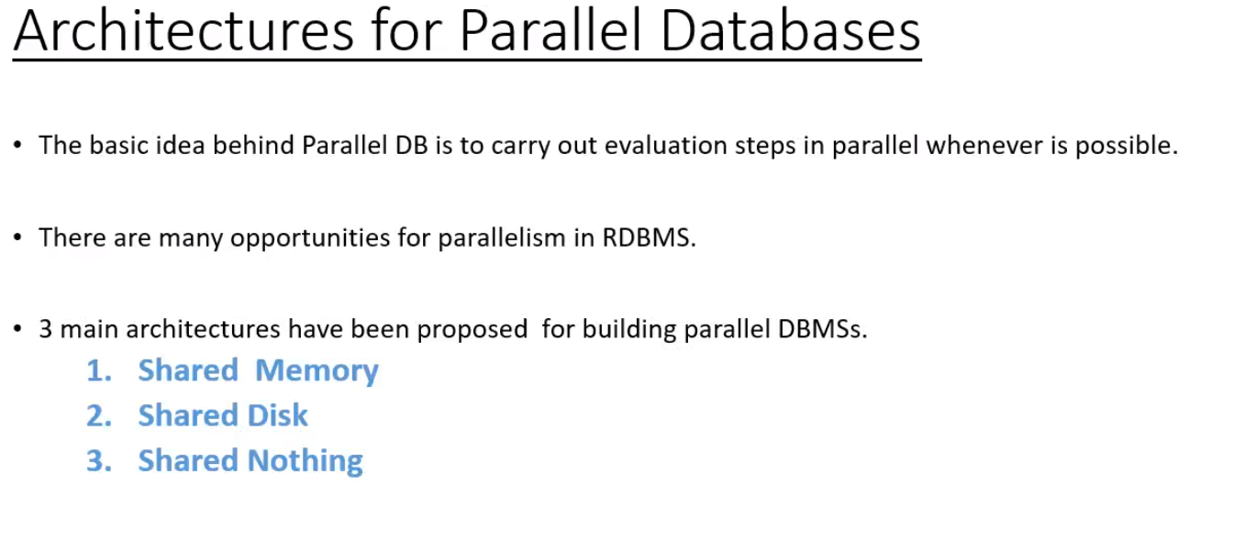

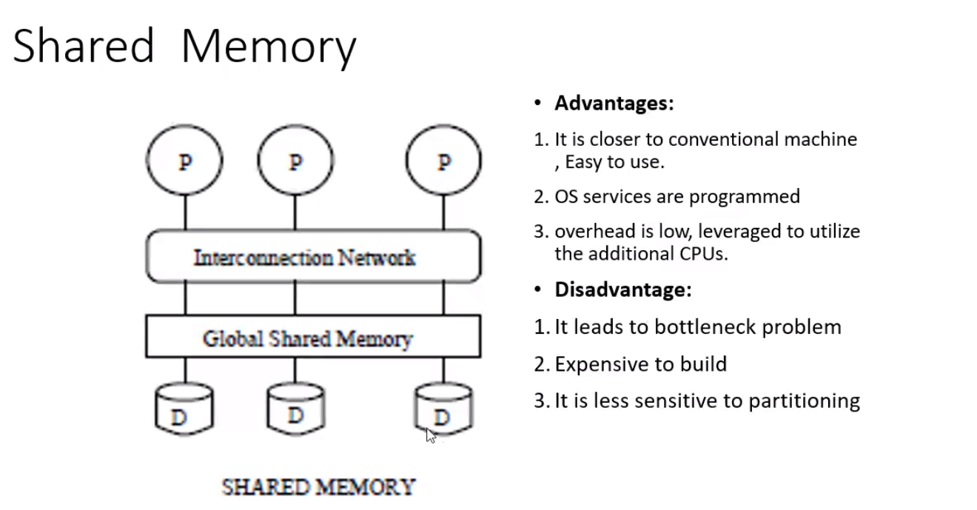

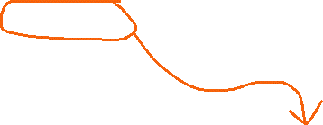

P1,P2 and P3 are sending queries simultaneously. But difficult to manage.

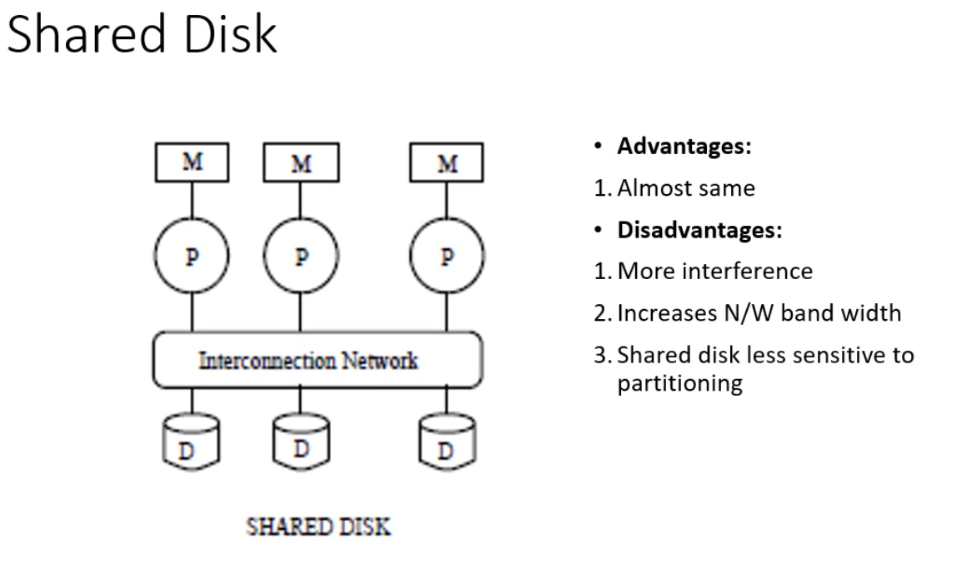

Every processor will have individual disk, the disk also can be shared.   
If P1’s disk is full, P1 can put its data in P2’s disk. [Should be partioned correctly to separate P1’s and P2’s data]

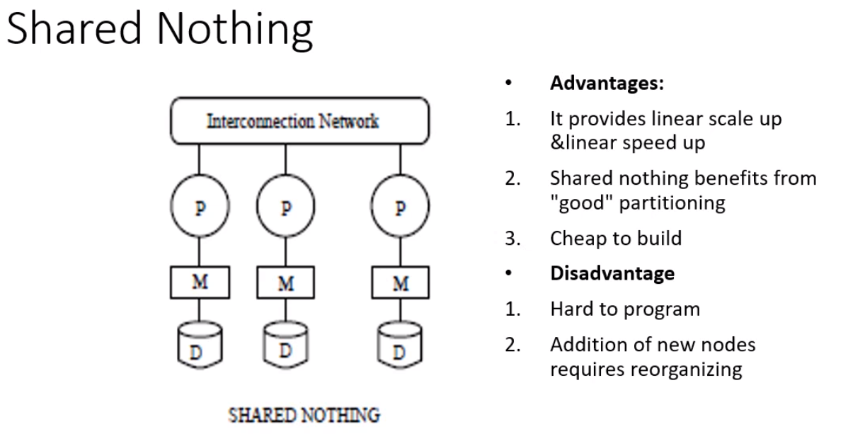

No sharing of the info.  
If the disk is full, some should be deleted and added. It cannot put the data into another disk

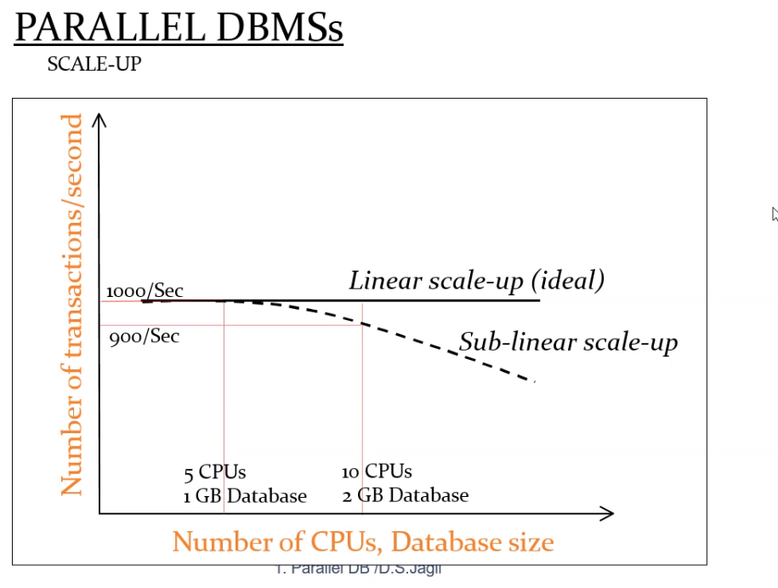

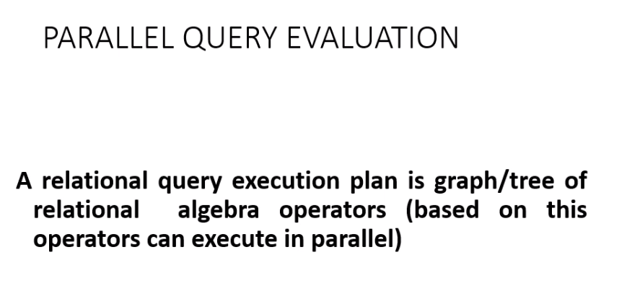

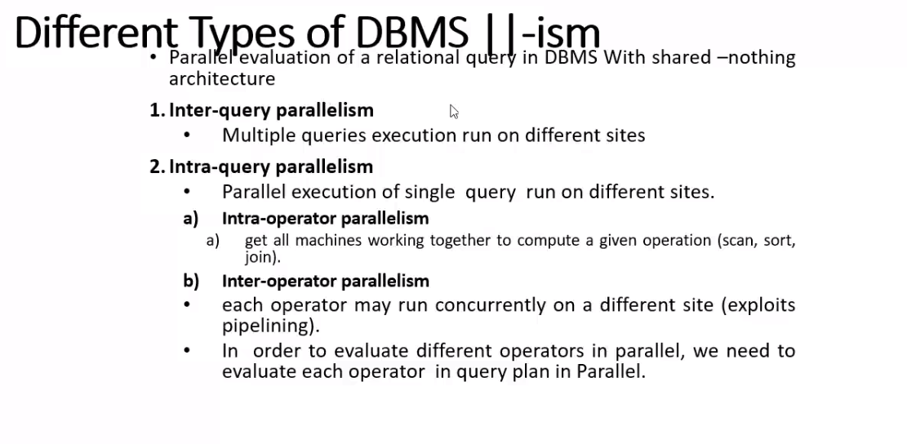

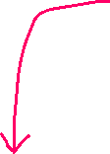

One single operations(sort,join,merge), for this all the systems will work together for this single query.  
Every operator will work concurrently.

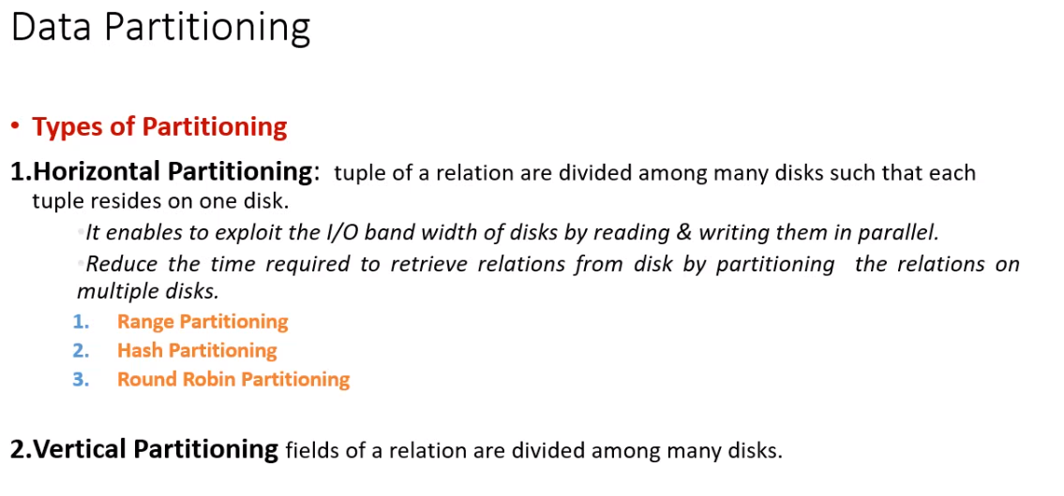

Horizontal portioning 🡪 tuples will be portioned   
Vertical portioning 🡪 attributes will be portioned   
[ should be Lossless join decomposition ]

Centralized DBMS 🡪 2 query (2 seconds) 🡪 one after the other  
Parallel DBMS 🡪 2 query (1 second) 🡪 parallellyx all will be executing.

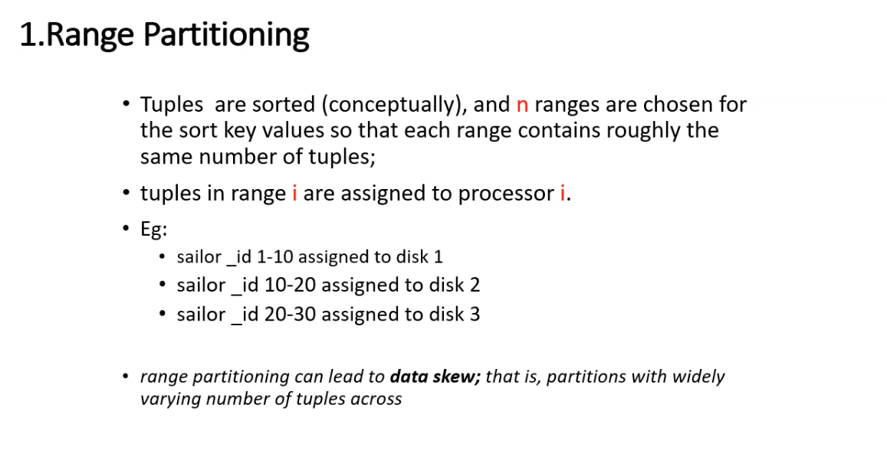  
1) Sort the records.  
2) Each range of tuples will be allocated to every processor.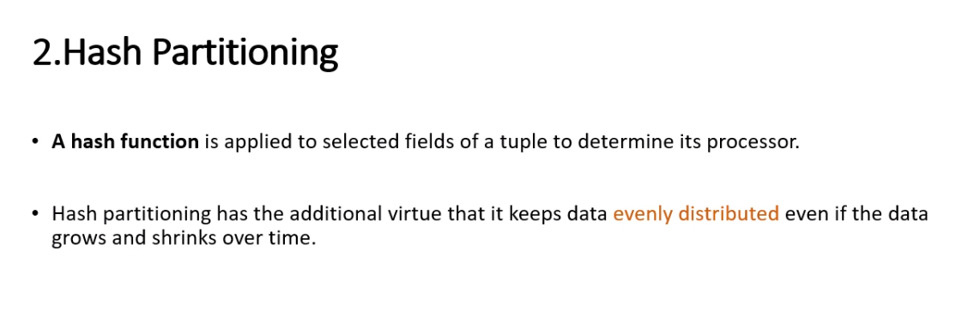  
data 🡪 distributed eventually.



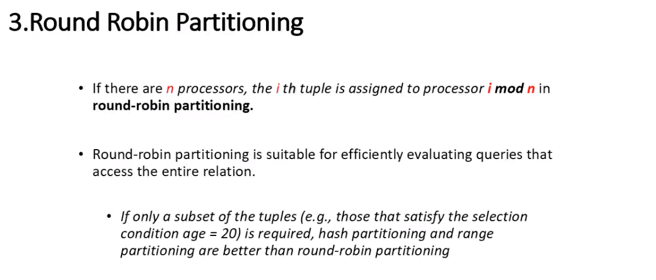

Eg: 11 tuples and 10 Processors  
(1 to 10 tuples) 🡪 (Processor P1 to P10)  
11th tuple 🡪 Processor P1

Subset of tuples 🡪 hash and range  
complete tuples 🡪 round-robin

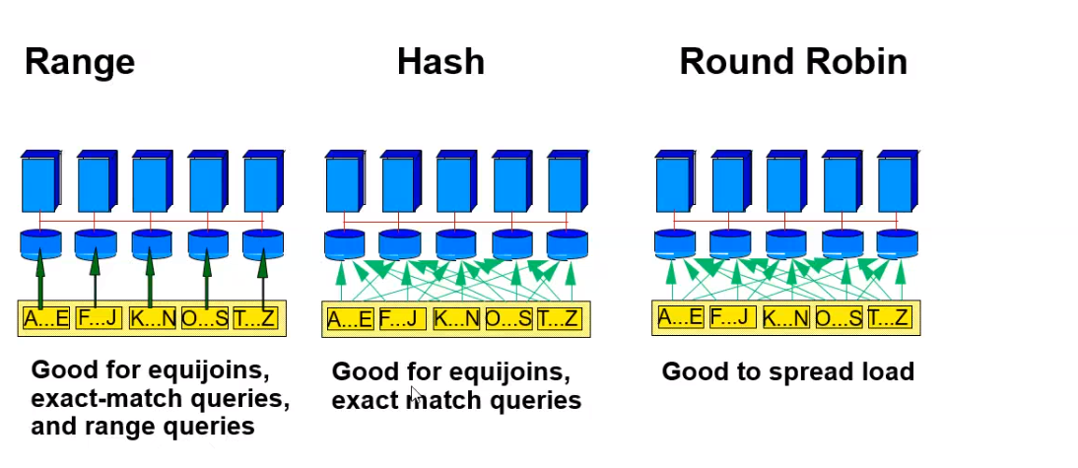

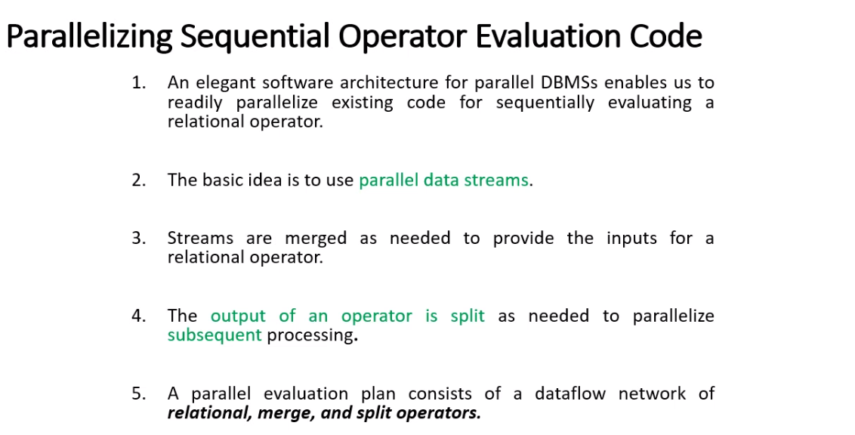

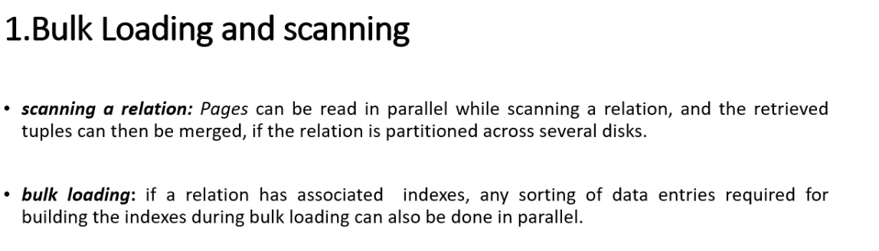



After scanning, we are merging 🡪 and then giving the index.



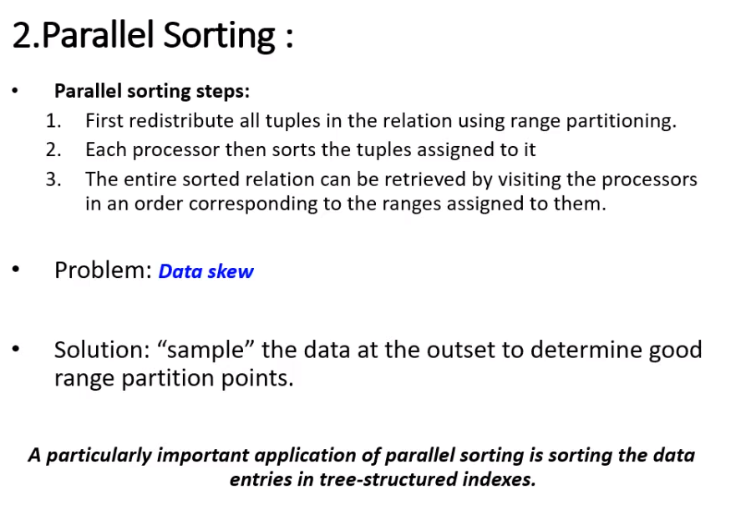



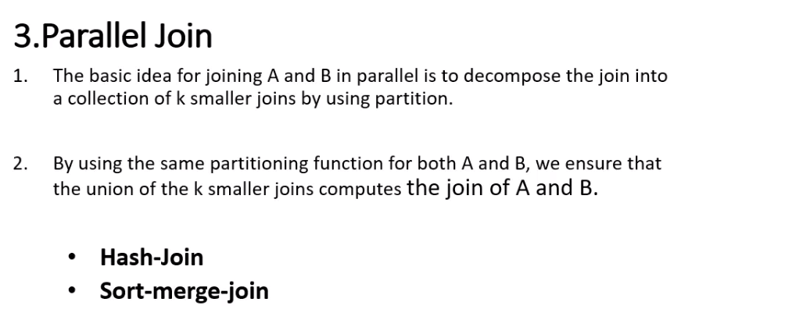

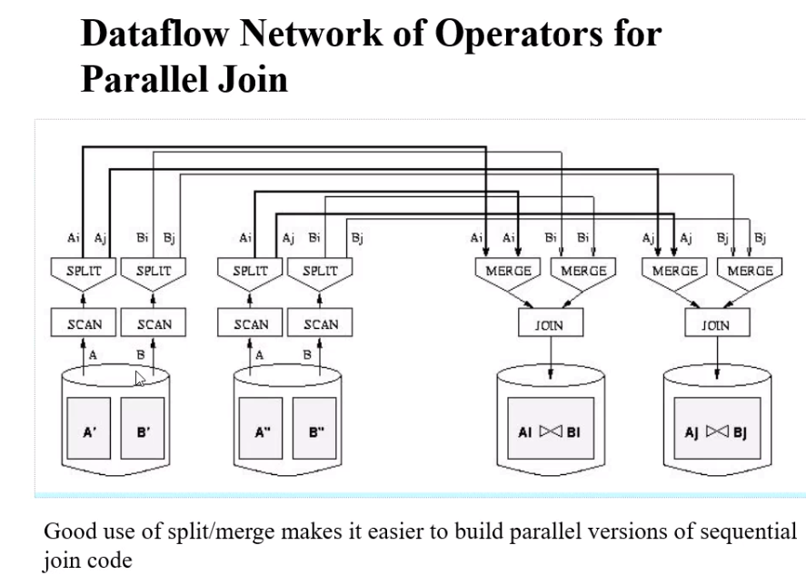

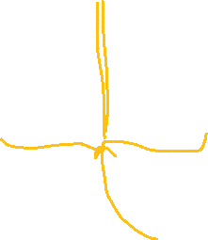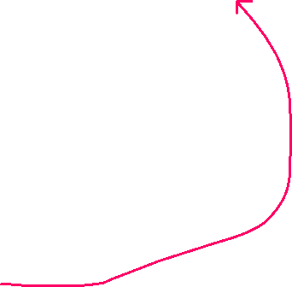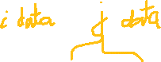

Having i and j separated 🡪 so sorted

